[Artificial Intelligence in Agriculture 5 (2021) 24–42](https://doi.org/10.1016/j.aiia.2021.01.004)

Contents lists available at [ScienceDirect](http://www.sciencedirect.com/science/journal/)

Artificial Intelligence in Agriculture

journal homepage: [http://www.keaipublishing.com/en/journa ls/artificial- intelligence- in-agriculture/](http://www.keaipublishing.com/en/journals/artificial-intelligence-in-agriculture/)

[](http://crossmark.crossref.org/dialog/?doi=10.1016/j.aiia.2021.01.004&domain=pdf)Prediction and data mining of burned areas of forest fires: Optimized data matching and mining algorithm provides valuable insight

David A. Wood ⁎

*DWA Energy Limited, 25 Badgers Oak, Bassingham, Lincoln LN5 9JP, United Kingdom*

a r t i c l e i n f o

*Article history:*

Received 27 October 2020

Received in revised form 5 January 2021 Accepted 8 January 2021

Available online 16 January 2021

*Keywords:*

Wildfire feature selection

Non-regression machine learning Data-matched prediction accuracy

Cumulative absolute error differentials Predicting highly skewed distributions

a b s t r a c t

An optimized data-matching machine learning algorithm is developed to provide high-prediction accuracy of total burned areas for specific wildfire incidents. It is applied to a well-studied forest-fire dataset from Portugal Montesinho Natural Park considering 13 input variables. The total burned area distribution of the 517 burn events in that dataset is highly positively skewed. The model is transparent and avoids regressions and hidden layers. This increases its detailed data mining capabilities. It matches the highest burned-area prediction accuracy achieved for this dataset with a wide range of traditional machine learning algorithms. The two-stage prediction process provides informative feature selection that establishes the relative influences of the input variables on burned-area predictions. Optimizing with mean absolute error (MAE) and root mean square error (RMSE) as separate objective functions provides complementary information with which to data mine each total burned- area incident. Such insight offers potential agricultural, ecological, environmental and forestry benefits by im- proving the understanding of the key influences associated with each burn event. Data mining the differential trends of cumulative absolute error and squared error also provides detailed insight with which to determine the suitability of each optimized solution to accurately predict burned-areas events of specific types. Such predic- tion accuracy and insight leads to confidence in how each prediction is derived. It provides knowledge to make appropriate responses and mitigate specific burn incidents, as they occur. Such informed responses should lead to short-term and long-term multi-faceted benefits by helping to prevent certain types of burn incidents being repeated or spread.

© 2021 The Author. Publishing services by Elsevier B.V. on behalf of KeAi Communications Co. Ltd. This is an open access article under the CC BY-NC-ND license (<http://creativecommons.org/licenses/by-nc-nd/4.0/>).

1. Introduction

Recent years have been unprecedented in the extent of burned areas of wildfires, particularly in forested regions across the world that in- creasingly impact substantial population areas. This highlights the ur- gent need to improve our ability to predict and better understand the factors influencing total burned areas likely to occur in certain condi- tions (Finney et al., 2013), and real-time, wildfire-spread modelling (De Gennaro et al., 2017). This requires efficient and penetrating data mining of datasets of historical wild-fire incidents. It is essential to iden- tify the key factors influencing the impacts of forest fires in specific loca- tions and climatic zones as global climate conditions seem likely to evolve rapidly (Liu and Wimberly, 2016; Young et al., 2017) and as human land use expands (Montgomery, 2014). Alternative methods continue to emerge to suppress (Houtman et al., 2013), to prevent and to simulate (Rios et al., 2019) wildfires. Although human-caused and lightning-caused ignitions are common features in forest fire

* Corresponding author.

*E-mail address:* [dw@dwasolutions.com](mailto:dw@dwasolutions.com).

initiation (Veraverbeke et al., 2017) a range of meteorological and envi- ronmental factors influence their ability to spread and the speed at which they spread. These factors include local climatic conditions, to- pography and vegetation type. Also, the condition and density of vege- tation are fundamental factors that influence the behavior of wildfires and their ultimate wide ranging impacts on surrounding agriculture, ecology, environments and forestry.

The majority of wildfires that spread rapidly occur in windy condi- tions. Forest wind profiles can be complex, especially in the sub- canopy due to vegetation structure (Moon et al., 2019). Topography, and in particular canyons and junctions between canyons, tend to be wildfire hotspots in hilly or mountainous terrains, where localized high winds fan flames (Raposo et al., 2018; Rodrigues et al., 2019). Inter- mittent and varying heat flux from wind-driven flames (Tang et al., 2019) and coherent structures within flames impacted by wind condi- tions (Miller et al., 2017) influence the directions in which wildfires propagate and at what rates. Smouldering and flaming wildfires behave quite differently (Santoso et al., 2019), and the spontaneous transition between the two states is also influenced by complex relationships be- tween the prevailing weather and environmental conditions (Yang et al., 2018).

<https://doi.org/10.1016/j.aiia.2021.01.004>

2589-7217/© 2021 The Author. Publishing services by Elsevier B.V. on behalf of KeAi Communications Co. Ltd. This is an open access article under the CC BY-NC-ND license ([http://](http://creativecommons.org/licenses/by-nc-nd/4.0/) [creativecommons.org/licenses/by-nc-nd/4.0/](http://creativecommons.org/licenses/by-nc-nd/4.0/)).

The rate of wildfire spread depends on a wide range of variables combining with wind speeds and directions, displaying complex non- linear interactions. The condition of the fuel bed (McAllister, 2019) and its geometry (McAllister and Finney, 2016) influence the spreading rate of wildfires. Likewise the wind-driven transportation of firebrands (Caton-Kerr et al., 2019; Tohidi and Kaye, 2017; Manzello and Suzuki, 2017) and the nature of the firebrands (Hedayati et al., 2019) impact how wildfires develop and spread in specific regions. The aerated condi- tion of the litter layer beneath the trees and shrubs, particularly its per- meability in broadleaf forests (Wang et al., 2019; Fehrmann et al., 2017), is influential because it affects the extent of wind driven convection through the fuel bed (De Gennaro et al., 2017).

This study is organized into the following sections:

* Literature review (Section 2)
* Materials and methods (Section 3)
* Results and discussion (Section 4)

1. Literature review

Forest fire prediction systems, especially the Forest Fire Weather Index (FWI) System developed for applications in Canada using mainly meteorological data (Stocks et al., 1989; Taylor and Alexander, 2006), and the Forest Fire Behavior Prediction (FBP) System developed for ap- plications in China incorporating satellite sensors (Zhang et al., 2011) are widely used. They are suitable and exploited for worldwide applica- tions (Di Giuseppe et al., 2018) as they combine a wide range of relevant input variables. Such systems and their component variables make it possible to compile datasets with historic information recording a wide range of prevailing conditions and geospatial data (Forsell et al., 2009; Alkhatib, 2014) linked to the total burned area resulting from each incident. Such datasets are conducive to machine-learning applica- tions attempting to predict total burned area based on specific condi- tions, and for data mining to extract useful comparative information relating specific events. Common challenges using such datasets are consolidating data from diverse sources (De Souza et al., 2015) and the positively skewed nature of burned area distributions (Cortez and Morais, 2007). This requires careful feature selection to generate man- ageable models. In some locations specific variables are known to be highly influential, e.g. vapor pressure deficit and fraction of spruce cover in the case of Alaska's boreal forests (Coffield et al., 2019).

There have been many attempts over recent decades to apply ma-

chine learning and simulation methods to assist in the prediction of for- est fires (Finney, 1998; Yongzhong et al., 2004) and to evaluate the feasibility of wildfire prediction (Malarz et al., 2002). Additionally, var- ious models have evolved to assess multiple aspects of environmental and ecological change influencing wildfire development (Recknagel, 2001). The machine-learning techniques evaluated include multi- variate regression, artificial neural networks (applying both multi- layer perceptrons and radial basis functions), support vector machines, decision trees, in some cases supported by genetic programming, ran- dom forest, and Markov chain decision process (Garzón et al., 2006; Cortez and Morais, 2007; Li et al., 2011; Sitanggang and Ismail, 2011; Castelli et al., 2015; Mcgregor et al., 2016). Airborne and satellite imag- ery to provide detailed geospatial, and other information (e.g. surface relative humidity, Peng et al., 2006)), are the focus of some wildfire ma- chine learning studies (Sehgal et al., 2006; Saranya and Hemalatha, 2012; Subramanian and Crowley, 2017, 2018) with some applying fuzzy logic techniques to generate total burned-area predictions (Angayarkkani and Radhakrishnan, 2009).

In recent years, a range of optimizers and machine learning models

have been employed to assist in wildfire prediction. These include ge- netic algorithms coupled with wind field and environmental models (Artes et al., 2016; De Gennaro et al., 2017). Some models distinguishing wind velocity and direction are exploited using domain decomposition

of linear relationships within datasets (Sanjuan et al., 2016) and probabilistic analysis (Quill et al., 2019). Zhang et al. (2019) developed a spatial prediction model for forest fire susceptibility employing a convolutional neural network verified with data from historic fire loca- tions in Yunnan Province, China. An adaptive neuro-fuzzy inference sys- tem (ANFIS) was applied to classify forest fire hotspot data in central Kalimantan, Indonesia (Wijayanto et al., 2017). Jaafari et al. (2019) eval- uated hybrid models combining neuro-fuzzy logic and metaheuristic optimization to predict the probability of wildfires spatially in the Hyr- canian region of Iran.

However, there is much room for progress and improvement in the prediction accuracy of total burned areas associated with specific wild- fires. To date, limited research has been conducted to explore the poten- tial of new machine-learning techniques that avoid regressions, hidden layers and focus on transparency, as well as accuracy of individual predictions.

A common characteristic of the machine learning techniques traditionally applied to predict total burned areas of forest fires from data-driven models is that they involve regression, correlation and/or statistical distribution analysis in their calculation processes, often with hidden layers and difficult to penetrate calculations contributing to the prediction of each forest fire event. Such models tend to be insuf- ficiently transparent in their calculations to be conducive to rapid and detailed data mining of the datasets they are modelling. In this study, a recently developed optimized data matching model, the transparent open box (TOB) network (Wood, 2018) is configured and developed specifically to predict and data mine a well-studied forest fire dataset (Cortez and Morais, 2007). This technique, for the first time applied here to assess a forest fire dataset, avoids using correlations, regressions or statistical relationships between its variables. By doing so, it readily reveals the details of each prediction it makes and the closely matched historical fires to each event. This makes the model much more condu- cive to detailed data mining applications, which are essential to better understand historical forest fire datasets.

1. Materials and methods
   1. *Optimized-data-matching algorithm configured for forest fire data mining*

The TOB machine-learning method is now well described and has been implemented with a range of dataset from different sectors (Wood, 2019a). Fig. 1 provides a summary of the TOB workflow config- ured to predict total burned area associated with forest fires based on forestry, weather and environmental variables. A novel aspect of the al- gorithm is that it is computed in two stages (1 and 2) and provides two estimates, the second optimized. Comparing the two-stage estimates with training and testing data subsets helps to identify and reject opti- mized solutions that overfit the underlying data variables.

TOB establishes the best (*Q* ≤10) data-record matches in a large training data subset for each specific data record in relatively small tuning subsets of data records (between about 100 and 150 data records based on sensitivity analysis). It does so by comparing the sums of the variable squared differences (*VSD*) for all the input variables between specific data records in the tuning subset with all the data records in the larger pool of training subset data records. Eq. (1) describes how weights are applied in the calculation to of the weighted sum of each VSD.

*n*=*N*

∑*VSD* = ∑ *VSD*(X*n*) (*Wn*) (1)

*jk jk*⁎

*n*=1

where

*N =* number of input variables.

*Xn =* normalized value of variable n.

*j* = *jth* tuning-subset data record (from small pool of data records).

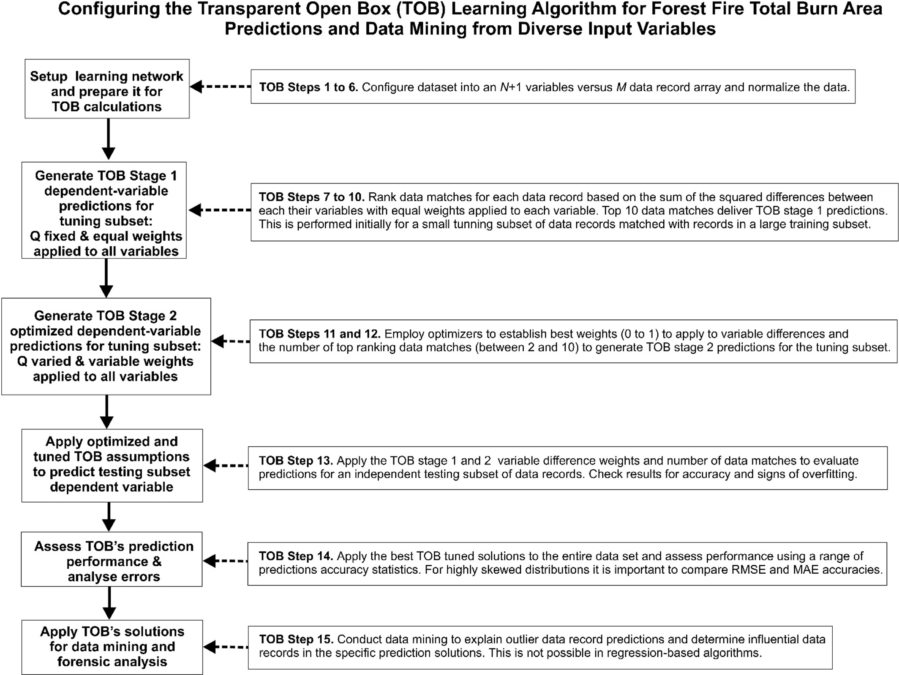

Fig. 1. TOB optimized data matching methodology configured for predicting and data mining highly skewed total burned areas in *forest-fire datasets.*

*k* = *kth* training-subset data record (from large pool of data records). *Wn* = weight applied to variable *n* in all data-record comparisons. In

*predicted*

*q*=1

*q*=*Q* h

i

TOB Stage 1 *Wn* is fixed at a constant value (e.g. 0.5) and Q (number of best matching records) is set to 10. In TOB Stage 2 variable weights are allowed to vary such that 0 < *Wn* ≤ 1 and Q is also allowed to vary

(Q ≤10) enabling the optimizer to minimize ∑*N VSD* .

(*XN*+1)*j* = ∑ (*XN*+1)*q*⁎ 1− *f q*

where

(3)

*n*=1 *jk*

Eq. (2) calculates the relative magnitude of ∑*VSE* for the best matching data records

*N + 1* = dependent variable (total burned area).

(*XN*+1)*q* = total burned area of *qth* of *Q* highest-matching training- subset data record.

(*XN*+1)*predicted* = predicted total burned area value for *jth* tuning-

h *r*=*Q* i *j*

*f jq* = ∑*VSDjq*/ ∑*r*=1 ∑*VSDjr*

where

(2)

subset data record.

Eqs. (1) to (3) are evaluated separately to calculate TOB Stage 1 (no optimizer; *Q* = 10, *Wn* = constant) and TOB Stage 2 (optimizer applied;

*q* = *qth* highest-ranked training-subset data record for the *jth* tuning- subset data record.

*r* = *rth* highest-ranking training-subset data record (Q ≤10) for the *jth*

tuning-subset data record.

2 ≤*Q* ≤10; 0 < *Wn* ≤ 1). Optimum *Q* and Wn values are located by the op- timizers to minimize the objective function. That objective function is usually root-mean-squared error (RMSE) or mean absolute error (MAE) of the dependent variable prediction; in this study total

*fjq*

= fractional contribution to VSD of *qth* highest-ranked training-

burned area.

subset data record for the *jth* tuning-subset data record, constrained

* 1. *Optimizers suitable for TOB applications*

such that *q*=*Q f*

∑

*q*=1

*jq* = 1.

Various functional optimization algorithms could be used to perform

The matching data record with the lowest ∑*VSDjk* has the lowest calculated *fjq*. Eq. (3) ensures that the training-subset data record with the lowest *fjq* value contributes the most to the total burned area predic- tion for the *jth* tuning-subset data record.

the TOB Stage 2 optimization routine. Wood (2019b) has demonstrated that standard Microsoft Excel Solver optimizers (Frontline Solvers, 2020) are adequate, but to extract metaheuristic profiling information (Wood, 2016) and to fully code the optimization process a customized

firefly optimizer and to fully code the optimizer customized firefly opti- mizer works well.

Small tuning subsets of data records selected to sample the full range

*Standard Deviation (SD):*

s∑ﬃﬃﬃﬃﬃﬃﬃ*n*ﬃﬃﬃﬃﬃ(ﬃﬃ*D*ﬃﬃﬃiﬃﬃ−ﬃﬃﬃﬃ*D*ﬃﬃﬃﬃ*m*ﬃﬃﬃﬃ*e*ﬃﬃ*a*ﬃﬃ*n*ﬃﬃﬃ)ﬃﬃ2ﬃﬃ

of total burned area values provide statistically repeatable total burned area predictions. That repeatability is confirmed using independent testing-subsets of data records involving about one hundred data re-

*SD* =

where

*i*=1

n−1

(10)

cords not involved in the algorithm-tuning routines. To monitor repeat- ability and expose overfitting five different cases are run each associated with different selections of tuning and testing subset data records. For each case three different optimizer algorithms were applied and each

*Di* is (*Xi* – *Yi)* for each (*ith*) data record of a dataset; and,

*Dimean* is the mean of the *Di* values of all the data records in a dataset

was run three times. This generated forty-five TOB-Stage-2 optimized tuned solutions to test. As well as applying those solutions to the inde- pendent testing subsets it is also informative to evaluate each optimized

*Dmean*

1 *n*

= *n* ∑(*Xi*−*Yi*) (11)

*i*=1

solution using the entire dataset (all data records). If the TOB stage 2 so- lutions generate lower prediction errors when applied to all data re- cords than the TOB Stage 1 solutions that verifies that the optimized solutions, found using small tuning subsets are not overfitting the

dataset as a whole.

*Correlation Coefficient (R) between variables Xi and Yi* (on a scale be- tween −1 and + 1).

*n*

∑(*Xi*−*Xmean*) (*Yi*−*Ymean*)

*i*=1

= sﬃﬃﬃ*n*ﬃﬃﬃﬃﬃﬃﬃﬃﬃﬃﬃﬃﬃﬃﬃﬃﬃﬃﬃﬃﬃﬃﬃﬃﬃﬃﬃﬃﬃﬃﬃ2ﬃﬃﬃﬃﬃﬃ*n*ﬃﬃﬃﬃﬃﬃﬃﬃﬃﬃﬃﬃﬃﬃﬃﬃﬃﬃﬃﬃﬃﬃﬃﬃﬃﬃﬃﬃﬃﬃﬃﬃ2ﬃﬃ

*R*

(12)

* 1. *Measures of burned area prediction accuracy for forest fire analysis*

( )

( )

∑ *Xi*−*Xmean* ∑ *Yi*−*Ymean*

*i*=1 *i*=1

The assessment of burned area prediction benefits from comparing a number of well-established metrics that compute prediction accuracy from different statistical perspectives. In this study the prediction accu- racy metrics defined in Eqs. (4) to (13) are calculated and assessed.

In these equations, *Xi* refers to the measured value and *Yi* the TOB predicted value of a data record *i* in the subset being considered.

*Mean Square Error (MSE):*

*n*

*MSE* 1 *X* − *Y* 4

= ∑ (( *i*) ( *i*))2 ( )

*n i*=1

*R* is expressed on a scale of −1 to +1.

*Coefficient of Determination* = *R2* (on scale between 0 and 1) (13)

* 1. *Characterization of a well-studied forest fire dataset from portugal*

Table 1 provides details and summary statistics for the 517 forest fire incidents recorded in the Montesinho Natural Park (Portugal) between January 2000 to December 2003 that resulted in 39 human deaths and damaged to about 5% of the forest (Cortez and Morais, 2007). The

*Root Mean Square Error (RMSE): RMSE* = ,ﬃMﬃﬃﬃﬃSﬃﬃEﬃﬃﬃ

(5)

total burned areas of the incidents in this dataset constitute a highly positive skewed, asymmetrical distribution requiring that metric to be better displayed and evaluated in terms of its natural logarithm (Fig. 2). About 48% of the recorded incidents resulted in small total

burned areas of less than 100 m2.

RMSE calculated with Eqs. (8) and (9). RMSE is used as the objective function of the TOB Stage 2 algorithm.

*Mean Absolute Error*

The data variables recorded in this dataset include spatial, temporal and meteorological factors. The four widely used wildfire indices FFMC, DMC, DC and ISI (defined in Table 1) are included as input variables in

this dataset. These indices are components of the Fire Weather Index

*MAE*

1 *n*

= *n* ∑|*Xi*−*Yi*| (6)

*i*=1

(Stocks et al., 1989; Taylor and Alexander, 2006). FFMC combines mea- surements of rainfall, relative humidity, temperature and wind speed to provide an indicator of the degree of moisture in forest floor litter, its

*Percent Deviation between measured and predicted values for data set record i (PDi):*

likelihood to ignite, and the rate of likely spread of a fire once ignited. DMC combines measurements of rainfall, relative humidity and temper- ature, while DC combines just rainfall and temperature. DMC and DC are

*PDi* =

*Xi*−*Yi* x 100 7

*Xi*

( )

typically used as indicators of prevailing moisture content in the forest floor organic layers. DMC and DC record conditions over much longer periods, 12 past days and 52 past days, respectively, compared to the

past 16 h involved in FFMC. ISI involves a correlation between FFMC

*Average Percent Deviation (APD):*

*n*

∑ *PD*

*APD*  *i*=1 i

=

n

(8)

and wind velocity and is used as an indicator of how quickly a fire is likely to spread.

This dataset is important for the current study because previous studies have published prediction accuracy of the total burned area (BA) applying several regression and/or statistically focused machine

*APD* combines both positive and negative percent deviations (Eq. (10)) and is expressed in percentage terms.

*Absolute Average Percent Deviation (AAPD):*

learning methods (Cortez and Morais, 2007; Castelli et al., 2015). The method evaluated include:

* Geometric Semantic Genetic Programming Decision Tree (GS-GP)

*AAPD* =

∑*n*

*i*=1

|*PD*i|

(9)

* Standard Genetic Programming Decision Tree (ST-GP)
* Support Vector Machine polynomial kernel (second degree) (SVM)

n

*AAPD* combines the absolute values of the percent deviations (Eq. (10)) and is also expressed in percentage terms.

* Random forests (RF)
* Multi-layer Perceptron Neural Networks (MLP-NN)
* Radial basis function neural network (RBF-NN)
* Linear regression (LR)

Table 1

Range, mean and units for the Montesinho Natural Park (Portugal) forest fire dataset for 2000 to 2003 (Cortez and Morais, 2007; UCI Machine Learning Repository, 2008) recording 517 separate fire incidents.

|  |  |  |  |  |  |  |  |  |
| --- | --- | --- | --- | --- | --- | --- | --- | --- |
| Variable code | Description | Unit | Min | P25 | P50 | Mean | P75 | Max |
| X | East-West Coordinate (1 to 9) | Integer series | 1 | 3 | 4 | 4.67 | 7 | 9 |
| Y | North-South Coordinate (1 to 9) | Integer series | 2 | 4 | 4 | 4.30 | 5 | 9 |
| Month | (1 to 12) | Integer series | 1 | 7 | 8 | 7.48 | 9 | 12 |
| Day | (1 to 7) | Integer series | 1 | 2 | 5 | 4.26 | 6 | 7 |
| FFMC | Fine Fuel Moisture Code | Index | 18.7 | 90.2 | 91.6 | 90.64 | 92.9 | 96.2 |
| DMC | Duff Moisture Code | Index | 1.1 | 68.6 | 108.3 | 110.87 | 142.4 | 291.3 |
| DC | Drought Code | Index | 7.9 | 437.7 | 664.2 | 547.94 | 713.9 | 860.6 |
| ISI | Initial Spread Index | Index | 0.0 | 6.5 | 8.4 | 9.02 | 10.8 | 56.1 |
| Temp | Temperature | oC | 2.2 | 15.5 | 19.3 | 18.89 | 22.8 | 33.3 |
| RH | Relative Humidity | % | 15 | 33 | 42 | 44.29 | 53 | 100 |
| Wind | Wind Speed | km h−1 | 0.4 | 2.7 | 4 | 4.02 | 4.9 | 9.4 |
| Rain | Rainfall | mm | 0 | 0 | 0 | 0.02 | 0 | 6.4 |
| BA | Total Burned Area | Ha | 0 | 0 | 1.52 | 3.04 | 7.57 | 1091.8 |
| BA (Ln) | Natural Logarithm of BA | Ln(Ha) | 0 | 0 | 0.42 | 1.11 | 2.02 | 7.00 |

Note: A burned area of zero refers to any event for which the BA is less 100 m2.

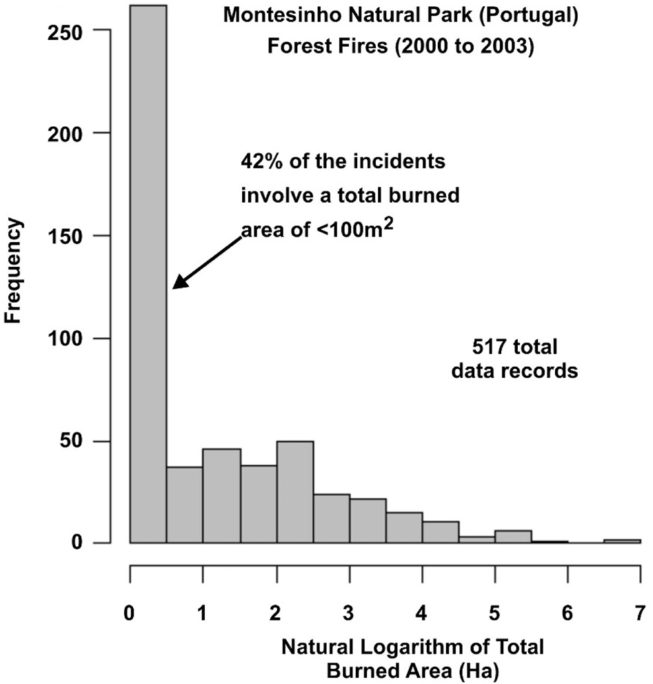

Fig. 2. The positively skewed distribution of total burned areas associated with forest fires in the Montesinho Natural Park (Portugal) from January 2000 to December 2003.

* Multiple regression (MR)
* Isotonic regression (IR)

The correlation matrices between these variables (Table 2) and some of their ratios (Table 3) reveal that they a very poorly correlated with BA. Correlation coefficients with BA are the highest for variables Month (0.1143), DMC (0.0672) and Wind (0.0670). These low correla- tions explain, to an extent, why correlation-based machine learning al- gorithm struggle to produce highly accurate predictions for this dataset. The ratios between input variables also show very low correlations with BA. The correlation coefficients with BA for ratios DC/Temp (0.0760), Wind/RH (0.0737), RH/Month (−0.0725) and Temp/Month (−0.0717) are slightly higher than those of their component variables (compare Tables 1 and 2) suggesting that they should be evaluated as

part of feature selection.

Variable relationships between burn area and the input variables are highly non-linear displaying substantial scatter. A key characteristic of the data set is that it is substantially positively skewed (Fig. 3). For this reason, previous prediction analyses of this dataset have elected to express the burn areas as their natural logarithms for the machine learning calculations. The natural logarithm of the total burned area is also used as the dependent variable in the TOB analysis presented here, although the prediction accuracy statistics achieved by those models are expressed in actual burned area (hectare) value terms.

Table 2

Correlation matrix for twelve independent variables associated with 517 forest fire data records with dependent variable (total burned area; BA). For input abbreviations see Table 1.

|  |  |  |  |  |  |  |  |  |  |  |  |  |  |  |  |
| --- | --- | --- | --- | --- | --- | --- | --- | --- | --- | --- | --- | --- | --- | --- | --- |
| Correlation coefficient (R) | X | Y | Month | Day | FFMC | DMC | DC | ISI | Temp | RH | Wind | Rain | BA | Rank for R  with BA |  |
| X | 1.0000 | 0.5395 | −0.0650 | −0.0249 | −0.0210 | −0.0484 | −0.0859 | 0.0062 | −0.0513 | 0.0852 | 0.0188 | 0.0654 | 0.0620 | 5 | X |
| Y |  | 1.0000 | −0.0663 | −0.0055 | −0.0463 | 0.0078 | −0.1012 | −0.0245 | −0.0241 | 0.0622 | −0.0203 | 0.0332 | 0.0388 | 9 | Y |
| Month |  |  | 1.0000 | −0.0508 | 0.2915 | 0.4666 | 0.8687 | 0.1866 | 0.3688 | −0.0953 | −0.0864 | 0.0134 | 0.1143 | 1 | Month |
| Day |  |  |  | 1.0000 | −0.0411 | 0.0629 | 0.0001 | 0.0329 | 0.0522 | 0.0922 | 0.0325 | −0.0483 | 0.0002 | 12 | Day |
| FFMC |  |  |  |  | 1.0000 | 0.3826 | 0.3305 | 0.5318 | 0.4315 | −0.3010 | −0.0285 | 0.0567 | 0.0468 | 8 | FFMC |
| DMC |  |  |  |  |  | 1.0000 | 0.6822 | 0.3051 | 0.4696 | 0.0738 | −0.1053 | 0.0748 | 0.0672 | 2 | DMC |
| DC |  |  |  |  |  |  | 1.0000 | 0.2292 | 0.4962 | −0.0392 | −0.2035 | 0.0359 | 0.0664 | 4 | DC |
| ISI |  |  |  |  |  |  |  | 1.0000 | 0.3943 | −0.1325 | 0.1068 | 0.0677 | −0.0103 | 11 | ISI |
| Temp |  |  |  |  |  |  |  |  | 1.0000 | −0.5274 | −0.2271 | 0.0695 | 0.0535 | 7 | Temp |
| RH |  |  |  |  |  |  |  |  |  | 1.0000 | 0.0694 | 0.0998 | −0.0537 | 6 | RH |
| Wind |  |  |  |  |  |  |  |  |  |  | 1.0000 | 0.0611 | 0.0670 | 3 | Wind |
| Rain |  |  |  |  |  |  |  |  |  |  |  | 1.0000 | 0.0233 | 10 | Rain |
| Total Burned | 0.0620 | 0.0388 | 0.1143 | 0.0002 | 0.0468 | 0.0672 | 0.0664 | −0.0103 | 0.0535 | −0.0537 | 0.0670 | 0.0233 | 1.0000 |  | BA |

Area

1. Results and discussion

Selected Variable Ratios

DCM/Month DC/Month Wind/Month RH/Month Temp/Month X/Month Wind/RH Wind/Temp DCM/Wind DC/Wind X/Wind RH/Temp DCM/Temp DC/Temp X/Temp

* 1. *TOB Machine Learning analysis to predict burn area of Forest fire dataset*

The dataset evaluated by the TOB algorithm includes all twelve inde- pendent variables for which measurements are recorded (Table 1) plus the Wind/RH ratio, making thirteen input variables in total. The ratio Wind/RH was selected because it showed the highest correlation coeffi- cient with BA (albeit a very low one) making it second to the “Month” variable in its degree of correlation with BA.

Table 3

Correlation matrix for selected ratios between the twelve independent variables associated with 517 forest fire data records with dependent variable (total burned area; BA). For input abbreviations see Table 1.

DC/Temp

X/Temp

BA

−0.295

−0.362

0.340

0.429

−0.171

0.640

0.016

0.662

−0.253

−0.264

0.266

0.731

0.004

0.189

1.000

0.069

0.154

0.579

−0.470

−0.299

−0.781

−0.464

−0.135

0.266

0.217

0.331

−0.021

0.295

0.632

1.000

0.036

0.024

−0.030

−0.073

−0.072

−0.016

0.074

0.104

0.003

−0.015

−0.023

−0.002

0.047

0.076

0.069

1.000

* 1. *Data matching feature selection and ranking of Most influential variables*

DCM/Temp

0.076

In complex datasets, with non-linear relationships between multiple input variables careful feature selection is essential. The highly skewed distribution of the dependent variable means that just a few data re- cords with extreme values are located in the distribution tail. The TOB method offers three distinct prediction-performance insights to feature selection based on the input variables it includes in its data matching procedure.

X/Wind

RH/Temp

−0.220

−0.263

0.302

0.667

−0.252

0.378

−0.236

0.614

−0.202

−0.224

0.003

1.000

0.001

0.061

−0.303

0.074

0.025

0.315

−0.435

−0.301

0.485

0.533

1.000

0.760

0.533

−0.317

−0.197

−0.473

−0.336

−0.227

0.011

0.455

0.238

−0.023

0.169

1.000

−0.023

−0.002

0.047

1. TOB Stage 1 BA predictions can involve data matching using all avail- able input variables, or in this case between 1 and 13 variables. The squared differences for the input variables selected are evaluated with equal variable error and Q fixed at 10.

DCM/Wind

DC/Wind

0.203

0.515

−0.594

−0.307

−0.309

−0.375

−0.467

−0.441

0.861

1.000

−0.015

1. TOB Stage 1 BA prediction constrained to use the squared differences for all 13 variables and Q fixed at 10. This provides a useful bench- mark comparison for prediction insight 1

0.541

0.461

−0.495

−0.254

−0.168

−0.298

−0.427

−0.409

1.000

0.003

1. TOB Stage 2 BA optimized predictions allows the number of best data matches and variable weights to vary (2 ≤*Q* ≤10 and 0 ≤*WN* ≤1) and considers all 13 variables. However, this prediction is constrained to use only the best record matches selected by prediction insight 1.

Wind/RH

Wind/Temp

−0.297

−0.418

0.518

0.233

−0.232

0.215

0.457

1.000

0.104

Sensitivity analysis comparing the predictions for these helps the feature selection to establish the best combination of variables to use for data matching in TOB Stage 1. Using all data records, variables are se- quentially eliminated from influencing the data matching process to es- tablish an order of influence for prediction insight 1. Table 4 compares the sequence of elimination of the input variables by this sensitivity analysis with the ranking of input variables in terms of their correlation coefficient with BA.

Temp/Month

X/Month

−0.039

−0.439

0.474

0.322

1.000

−0.254

−0.520

0.611

0.683

0.508

1.000

−0.144

−0.260

0.442

−0.212

0.180

0.000

1.000

−0.072

−0.016

0.074

Tables 4 and 5 reveal that the 1-Var sensitivity-case model (with DC only used for TOB Stage 1 data matching) generates the lowest RMSE value for BA prediction by TOB Stage 1. It also achieves the lowest RMSE and MAE values for BA by TOB Stage 2. Fig. 3 illustrates the results of the feature selection analysis for TOB data matching for all thirteen sensitivity-case models evaluated in terms of MAE and RMSE. All model structures evaluated achieve credible performance accuracy in terms of RMSE for TOB Stage 2 analysis. Models 1-Var, 2-Var and 3- Var provide superior TOB Stage 2 prediction performance accuracy for BA in terms of MAE for models with RMSE as the objective function (Fig. 3A). Models 1-Var and 3-Var also provide superior TOB Stage 2 pre- diction performance accuracy for BA in terms of RMSE (Fig. 3B). For these reasons a 1-Var (DC) model is evaluated in more detail for this study.

DCM/Month

DC/Month

Wind/Month

RH/Month

−0.251

−0.630

1.000

−0.235

−0.364

0.522

1.000

0.533

1.000

0.024

−0.030

−0.073

* 1. *RMSE versus MAE as objective functions for predicting highly skewed variable distributions*

Correlation Coefficient (R)

DCM/Month DC/Month Wind/Month RH/Month Temp/Month X/Month Wind/RH Wind/Temp DCM/Wind DC/Wind X/Wind RH/Temp DCM/Temp DC/Temp X/Temp

Total Burned Area

1.000

0.036

RMSE is typically more sensitive to predictions of individual data re- cords that generate high errors than MAE. This is because those rela- tively few points with high prediction error values are squared as part of the RMSE calculation. Most of those high error points are associated with few high total burned area events located in the right-side tail of

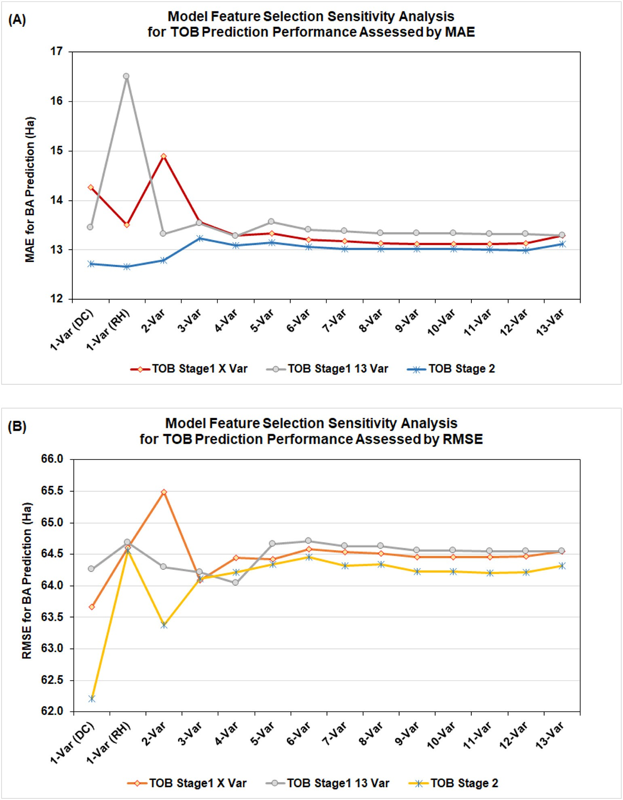

Fig. 3. Comparison of feature selection analysis for TOB data matching for BA predictions: (A) for MAE; (B) for RMSE which is the objective function that is minimized for TOB stage 2 optimization in this sensitivity analysis.

the total burn area distribution in the positively skewed distribution considered here. This fundamental characteristic tends to make RMSE a more effective optimization objective function for such highly skewed datasets than MAE. However, MAE is also a useful objective function to consider as it provides a distinctive insight.

Fig. 4 illustrates the significance of prediction error contributions, in terms of absolute error values, across the highly skewed BA distribution studied. It also highlights the BA prediction improvements achieved by the TOB Stage 2 optimizer. Some70% of the data records are associated with BA prediction errors of ≤5Ha. The TOB stage 2 solution improves on the TOB Stage 1 solution by substantially reducing the absolute er- rors for a substantial number of data records with prediction errors of less than 5 Ha. It is reassuring that the model is able to predict BA for 70% or so of the data records to an accuracy of 5 Ha. This generates con- fidence in applying the model for the majority of fires that result in

relatively small burn areas. Burn events with prediction errors >12.72 Ha constitute only about ~14% of the data records for this best performing prediction model (Table 4).

* 1. *Burned area prediction accuracy comparisons with Machine Learning algorithms*

The prediction accuracy of the TOB model compares favourably with that published for this same dataset using a range of regression and sta- tistical based machine learning algorithms applied to all twelve vari- ables with and without feature selection (Cortez and Morais, 2007; Castelli et al., 2015). Cortez and Morais (2007) applied a trial and error feature selection procedure involving the evaluations of four dis- tinct combinations of some of the input variables were considered. Their feature selection analysis identified a high-performing SVM

*D.A. Wood*

*Artificial Intelligence in Agriculture 5 (2021) 24*–*42*

31

Table 4

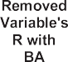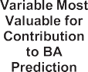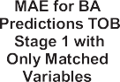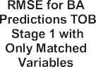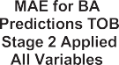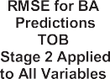Results of sequential removal of low contributing variables to identify TOB data-matching models with less variables. The earlier an input variable is removed in this sequential analysis gen- erally the less it is contributing to generate high performing data matches. Those variables contributing most to prediction accuracy for specific model structures are also identified and, for the most part, they are the variables with the higher correlations with the BA dependent variable. Although that is not the case for variable Y.



Notes: (1) This analysis helps in the selection of the most promising feature selection for the TOB data matching model that minimizes RMSE (and MAE) for all 517 data records in the dataset. This is achieved by removing the lowest contributing feature from one case to the next. (2) Based on TOB sensitivity analysis data matching with a 1-Var model (DC only) is the most promising for generating low RMSE (and MAE) BA predictions for the dataset. For high performing models, the backgrounds of their superior results are highlghted in this table.

Table 5

Results of sequential removal of low contributing variables to form TOB stage 1 data matching models with less variables: TOB Stage 1 and Stage 2 prediction performance compared in terms of MAE and RMSE. The TOB Stage 2 analysis uses RMSE as its objective function for these model results.

RMSE and MAE prediction accuracies compared for TOB solutions to aid feature selection

Case Variables used for data

|  |  |  |  |  |  |  |
| --- | --- | --- | --- | --- | --- | --- |
| MAE for BA predictions | MAE for BA predictions TOB | MAE for BA |  | RMSE for BA predictions | RMSE for BA predictions TOB | RMSE for BA |
| TOB stage 1 with only | stage 1 with using all variables | predictions |  | TOB stage 1 with only | stage 1 with using all variables | predictions |

MAE values of solutions optimized with RMSE RMSE optimization (as TOB objective function)

|  |  |  |  |  |  |  |  |
| --- | --- | --- | --- | --- | --- | --- | --- |
|  | matching | matched variables | on matched records | TOB stage 2 | matched variables | on matched records | TOB stage 2 |
| 13-Var | 13 | 13.292 | 13.292 | 13.124 | 64.550 | 64.550 | 64.315 |
| 12-Var | 12 | 13.128 | 13.323 | 12.991 | 64.473 | 64.544 | 64.219 |
| 11-Var | 11 | 13.117 | 13.321 | 13.003 | 64.462 | 64.550 | 64.200 |
| 10-Var | 10 | 13.119 | 13.341 | 13.015 | 64.461 | 64.561 | 64.227 |
| 9-Var | 9 | 13.118 | 13.340 | 13.019 | 64.461 | 64.561 | 64.231 |
| 8-Var | 8 | 13.136 | 13.341 | 13.016 | 64.519 | 64.624 | 64.336 |
| 7-Var | 7 | 13.181 | 13.384 | 13.014 | 64.532 | 64.626 | 64.323 |
| 6-Var | 6 | 13.212 | 13.407 | 13.057 | 64.582 | 64.711 | 64.454 |
| 5-Var | 5 | 13.329 | 13.570 | 13.152 | 64.423 | 64.665 | 64.336 |
| 4-Var | 4 | 13.287 | 13.275 | 13.088 | 64.442 | 64.047 | 64.214 |
| 3-Var | 3 | 13.571 | 13.539 | 13.240 | 64.085 | 64.212 | 64.114 |
| 2-Var | 2 | 14.904 | 13.324 | 12.797 | 65.485 | 64.298 | 63.379 |
| 1-Var (RH) | 1 (RH) | 13.502 | 16.501 | 12.664 | 64.600 | 64.689 | 64.563 |
| 1-Var (DC) | 1 (DC) | 14.265 | 13.443 | 12.717 | 63.667 | 64.262 | 62.213 |

Notes: (1) These results identify the solutions that are best able to minimize RMSE and MAE for all 517 data records in the dataset. (2) Based on TOB data matching sensitivity analysis the 1-Var model (DC only for record matching) is the most promising for generating low RMSE for BA predictions. On the other hand, the 1-Var model (RH only) for record matching is the most promising for generating low MAE for BA predictions for the dataset.

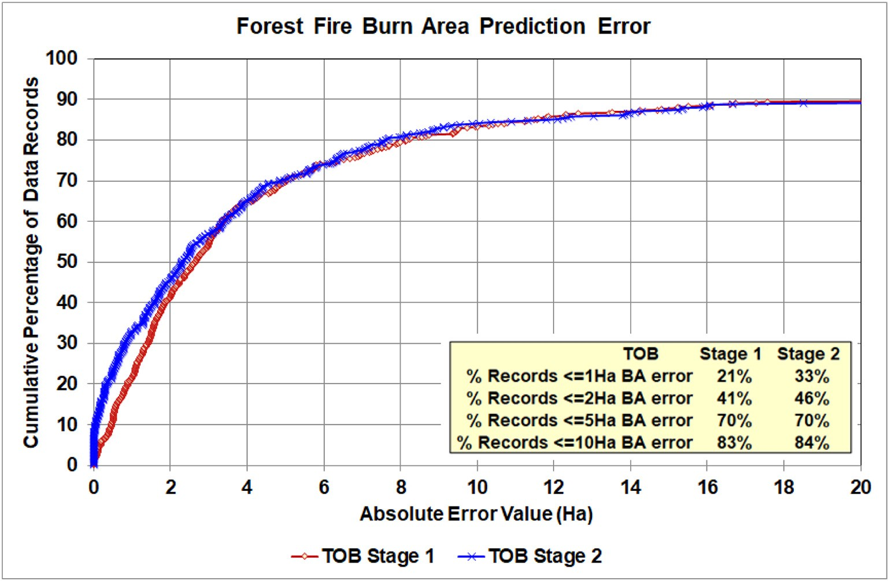

Fig. 4. Cumulative prediction error curve for the best TOB solutions optimized for MAE (MAE = 12.717 Ha; 1-Var (DC) model applied to all 517 data records) distinguishing TOB Stage 1 and Stage 2 solutions.

solution involving just four direct weather inputs (i.e. temperature, rain, relative humidity and wind speed) that performed well when consider- ing just wildfires with small-burned areas.

The optimum TOB model achieves a more accurate best RMSE (62.21 Ha; 1-Var (DC) model), when applied to the full dataset, compared to the best RMSE value for published results for other machine learning al- gorithms (i.e., RMSE = 63.7 Ha for the SVM model of Cortez and Morais, 2007). That optimum TOB model achieves a similar best MAE of 12.717 Ha applied to the full dataset. This almost matches the best MAE value for published results for other machine learning algorithms (i.e., MAE = 12.71 Ha for their SVM model of Cortez and Morais,

2007). Other machine-learning models evaluated in that study only achieved MAE values ranging from 13.08 Ha to 18.61 Ha.

These prediction accuracy comparisons confirm that the TOB model can generate prediction accuracy for the total burned area for the dataset studied comparable to the best prediction accuracy generated by a range of regression and/or statistical based machine learning algo- rithms. Moreover, the TOB model has the additional benefit of transpar- ency and forensic access to the components involved in each of its predictions. This additional attribute, which is considered a vital ecolog- ical benefit for forest-fire datasets, because it facilitates data mining and yields greater insight to the similarities of specific events with other burn events recorded in the dataset. It also reveals over-fitting as and

when it occurs. These additional attributes and their value are explored in Section 4.5. The regression and/or statistical based machine learning algorithms, for the most part, generate individual predictions in a “black-box” manner, which limits their usefulness in some of these key data mining tasks.

* 1. *Employing small tuning and testing subsets to find high performing pre- diction solutions*

A key question to evaluate for highly skewed distributions is, can the tuning of multiple small subsets of data records reveal solutions that can be meaningfully applied to predict the dataset as a whole, avoiding both overfitting and under fitting? The TOB 1-Var (DC) model has been con- figured to tune and test fifty cases involving tuning subsets of 100 data records (about 19% of the full dataset) and tested with fifty independent testing subsets (100 data records extracted distinctly from the dataset without replacement). This sampling of the dataset means that only 60% of the data records remain as the training data against which the tuned subsets are matched and optimized. Each relatively small tuning and testing subset selected in each case evaluated is spread across the entire BA value range. This is achieved so that it is impossible for the same records to be present in more than one of the testing, training or tuning subsets in each case. Each tuned subset is optimized twice, once with RMSE as the objective function and once with MAE as the ob- jective function.

Tables 6 and 7 display the key prediction performance statistics for the optimized solutions (both MAE and RMSE) found for the 50 cases and evaluated against the 100-data-record testing subsets and the full 517-data-record dataset, respectively. It apparent that there is less dis- persion of prediction accuracy for those models optimized with RMSE as the objective function (left-side Tables 6 and 7), compared with those optimized with MAE as the objective function. However, the MAE optimized cases find slightly lower MAE and RMSE best cases. Overall, MAE and RMSE find similar minimum (best) solutions for both MAE and RMSE suggesting that both are viable objective functions for TOB to optimize.

Table 8 lists the variable weights applied to the best TOB Stage 2 so- lutions found by sensitivity analysis (Table 5) and the tuning subset analysis (Table 7). The TOB Stage 1 data matching is restricted to just one variable (DC) for establishing the ten closest matching data records. Nevertheless, the TOB Stage 2 solutions have then gone on to exploit most of the thirteen input variables in the best-matching data records available to improve their prediction performance.

The best MAE values achieved by the TOB model (12.72 to 13.56 Ha, Table 8) straddle the the mean value achieved by 50 testing subsets (MAE =12.9 Ha) of the best performing GS-GP decision tree model re- ported by Castelli et al. (2015). The other machine learning models

evaluated in that study achieved mean MAE values ranging from 13.6 to 33.8 Ha.

* 1. *Data mining of the high-performing burned area prediction solutions*
     1. *Data mining to assess data records established as best prediction matches*

In data mining terms, the TOB model can go far beyond total burn area predictions with this and other forest fire datasets. It can provide information concerning the broader similarities between conditions and outcomes associated with specific fire incidents alongside each pre- diction. For the TOB algorithm to data mine the forest fire dataset, se- quential sample numbers (identifiers) 1 to 517 have been assigned to each data record in the order in which they are listed in the UCI database file (UCI Machine Learning Repository, 2008).

Some details of the TOB prediction analysis for two representa- tive data records (#144 in Table 9; #369 in Table 10) illustrate the some of the detailed information that TOB makes available for each stage of its prediction analysis. The upper half of Tables 9 and 10 shows the TOB Stage 1 prediction with the BA(Ln) prediction calcu- lations with the values expressed in normalized terms (−1,+1) before being converted to actual BA(Ln) values (0 to 7 scale). The lower half of Tables 9 and 10 shows the TOB Stage 2 BA (Ln) predic- tion calculations. The last three lines of the table convert the depen- dent variable values (actual and predicted) into non-logarithmic terms. The TOB Stage 2 solution used for both #144 and #369 is the “ Best Solution Found” column of Table 8 (i.e. optimizing all 517 dataset records for 1-Var (DC)).

The sum of the squared error term (SumE) in the fourth column from the right in Tables 9 and 10 combines the differences for each input variable between the records being matched. The individual vari- able differences can be easily accessed in the TOB model but are not shown in these tables. It is the last three columns on the right side of these tables that contain the key calculations that establish what frac- tional contribution each matching data record makes to the data record being predicted. Letter formula are shown above these three columns in Tables 9 and 10 to explain these calculations.

There is nothing unusual about the two data records considered (#144 and #369) and the TOB algorithm provides predictions with rel- atively low errors for both of them. There is an improvement on the ini- tial TOB Stage 1 predictions in both cases by the adjusted weights (defined by the TOB Stage 2 solution applied with Q = 6) for the vari- able errors used in the TOB Stage 2 predictions. The TOB Stage 1 predic- tions list the top-ten matching data records and display them in descending rank order. The column second from the right shows the fractional contribution of each matching data record to the BA (Ln) pre- diction and those contributions are arranged in descending order for the

Table 6

Prediction accuracy achievements for the best-case solutions established using 100-data-record tuning subsets, matched with the optimum TOB model structure (TOB Stage 1 data matching restricted to variable DC) and tested against independent 100-data-record testing subsets.

Prediction accuracies achieved for independent testing subsets

Statistics for solutions from 50 (100-record) tuned subsets TOB Stage 2 solution:

Optimized for RMSE

TOB stage 1 solution (1-Var (DC only) mean TOB stage 2 solution: optimized for MAE

MAE (Ha) RMSE (Ha) MAE (Ha) RMSE (Ha) MAE (Ha) RMSE (Ha)

5.992 11.75

|  |  |  |  |  |  |
| --- | --- | --- | --- | --- | --- |
| Minimum | 4.603 | 9.11 | ← Best Case → | 4.433 | 9.06 |
| 25 Percentile | 4.854 | 9.86 | All solutions tested with 100-data record independent testing | 5.317 | 11.57 |
| 50 Percentile | 5.597 | 11.95 | subsets | 6.344 | 12.72 |
| Mean | 5.758 | 11.79 |  | 6.037 | 13.08 |
| 75 Percentile | 6.378 | 13.42 |  | 6.856 | 15.27 |
| Maximum | 7.576 | 17.92 |  | 7.623 | 19.89 |
| Standard deviation | 0.849 | 2.097 |  | 0.965 | 2.763 |

Notes: (1) Assessed using testing subsets with 100 data records not used in the TOB tuning process. (2) Accuracies refer to total burned area (BA) predictions. (3) The tuned TOB solution used is that Initially matched using 1-Var (DC only).

Table 7

Prediction accuracy achievements for the best-case solutions established using 100-data-record tuning subsets, matched with the optimum TOB model structure (TOB Stage 1 data matching restricted to variable DC) and tested against all 517 data records.

|  |  |  |  |  |  |  |  |  |  |  |
| --- | --- | --- | --- | --- | --- | --- | --- | --- | --- | --- |
|  | Prediction accuracies achieved for all data records |  | | | | | | | | |
| Statistics for solutions from 50 (100-record) tuned subsets | TOB stage 2 solution: optimized for RMSE | |  | TOB stage 1 solution: |  |  | TOB Stage 2 Solution: Optimized for MAE | |  |
|  | MAE (Ha) RMSE (Ha) | |  | MAE (Ha) | RMSE (Ha) |  | MAE (Ha) RMSE (Ha) | |  |
|  |  |  | |  | 14.265 | 63.67 |  |  | |  |
| Minimum | | 13.086 | 63.26 | ← Best Cases → | | | 13.026 | | 61.88 | |
| 25 Percentile | | 13.288 | 64.35 | All solutions applied to all data records in the ful dataset | | | 13.491 | | 62.90 | |
| 50 Percentile | | 13.407 | 64.49 |  | | | 13.578 | | 64.61 | |
| Mean | | 13.447 | 64.33 |  | | | 13.697 | | 64.08 | |
| 75 Percentile | | 13.561 | 64.57 |  | | | 13.770 | | 64.74 | |
| Maximum | | 14.153 | 65.25 |  | | | 15.848 | | 70.88 | |
| Standard deviation | | 0.239 | 0.502 |  | | | 0.444 | | 1.435 | |

Notes: (1) Assessed using all 517 data records in the studied dataset. (2) Accuracies refer to total burned area (BA) predictions. (3) The tuned TOB solution used is that Initially matched using 1-Var (DC only).

Table 8

TOB Stage 1 and Stage 2 solutions achieving the highest BA prediction accuracy. Note that TOB Stage 1 itself achieves high prediction accuracy. Details of high-performing TOB solutions

|  |  |  |  |  |  |  |  |  |
| --- | --- | --- | --- | --- | --- | --- | --- | --- |
|  | | For data matching TOB stage 1 solution | Low RMSE achieved (Evol 2_6) | Low MAE achieved (Evol2_24) | RMSE optimized for all 517 records | Low MAE achieved (GRGM4_10) | Lowest RMSE achieved (EvolM4_15) |  |
|  | MAE (Ha) | 14.265 | 13.098 | 13.086 | 12.717 | 13.026 | 13.561 |  |
|  | RMSE (Ha) | 63.667 | 63.25619 | 63.539 | 62.213 | 63.019 | 61.877 |  |
|  | Q | 10 | 10 | 10 | 6 | 9 | 4 |  |
| Only DC Used Best Solutions Optimized for RMSE Best Solution Found Best Solutions Optimized for MAE | | | | | | | | |
| X Wt | | 0 | 0 | 0.0025950 | 0.0435660 | 0.0321675 | 0.0846351 |  |
| Y Wt | | 0 | 0.921672 | 0.9260039 | 0.7865996 | 0.9999999 | 0.6746566 |  |
| Month Wt | | 0 | 0.554625 | 0.4137009 | 0.0036408 | 0.1949935 | 0.2615751 |  |
| Day Wt | | 0 | 0.040349 | 0.0147467 | 0.1553836 | 0.0588744 | 0.7062877 |  |
| FFMC Wt | | 0 | 0.535292 | 0.4969708 | 1 | 0.3405357 | 0.6766137 |  |
| DMC Wt | | 0 | 0.142199 | 0 | 0.0000491 | 0 | 0 |  |
| DC Wt | | 0.5 | 0.392132 | 0.3890379 | 0 | 0.6387197 | 0.4658374 |  |
| ISI Wt | | 0 | 0.666055 | 0.6605516 | 0.3231543 | 0.1588633 | 0.5557298 |  |
| Temp Wt | | 0 | 0.030889 | 0 | 0.0008815 | 0.0141902 | 0.0088463 |  |
| RH Wt | | 0 | 0.629962 | 0.3742943 | 0.4107742 | 0.9999999 | 0.7566496 |  |
| Wind Wt | | 0 | 0.379060 | 0.4062201 | 0.1439708 | 0.1378218 | 0.0113238 |  |
| Rain Wt | | 0 | 0.522364 | 0.5894075 | 1 | 0.9671547 | 0.7104992 |  |
| Wind/RH Wt | | 0 | 0 | 0.0040449 | 0.0749174 | 0.0425287 | 0.4493523 |  |

Notes: (1) Assessed using all 517 data records in the studied dataset. (2) Accuracies refer to total burned area (BA) predictions. (3) 1-Var (DC only) solutions derived by TOB tuning subsets with just 100 data records.

TOB Stage 1 calculation. For data record #144 the top three matching re- cords contribute ~77% to the BA (Ln) TOB Stage 1 prediction. This changes to ~63% for the three matching solutions with the lowest squared errors contributing to the BA (Ln) TOB Stage 2 prediction. On

Table 9

Characteristics of data records that are difficult to fit for the high-performing 1-Var (DC) TOB solutions, or substantially influence those fits.

Problematic data records for high-performing TOB solutions

|  |  |  |  |  |  |
| --- | --- | --- | --- | --- | --- |
| the other hand, for data record #369 the top three matching records contribute ~91% to the BA (Ln) TOB Stage 1 prediction. This decreases | Ascending BA value sequence number | Dataset data record number | DC | BA | BA (Ln) |
| to 88% for the BA (Ln) TOB Stage 2 prediction. | 21 | 21 | 692.6 | 0 | 0 |
|  | 94 | 94 | 601.4 | 0 | 0 |
|  | 104 | 104 | 674.4 | 0 | 0 |
| *4.6.2. Identifying the Most influential data Records for Specific Prediction* | 197 | 399 | 715.1 | 0 | 0 |
| *Solutions* | 213 | 433 | 698.6 | 0 | 0 |
| It is insightful to conduct comparative analysis of the cumulative MAE and RMSE solutions for specific high-performing prediction solu- | 287  308  497 | 154  164  228 | 692.3  674.4  480.8 | 2.46  2.95  59.30 | 0.90  1.08  4.08 |
| tions, such as those displayed in Table 8. For the data record sequence | 502 | 230 | 480.8 | 72.30 | 4.28 |
| 1 to 517 (arranged in ascending order of BA values) each MAE (or | 509 | 235 | 674.4 | 155.88 | 5.05 |
| RMSE) absolute error is progressively added to the previous cumulative | 517 | 239 | 674.4 | 1091.84 | 7.00 |
| value through the BA ranked (lowest to highest) sequence. The “Best Some Influential Matching Records Selected for Problematic Predictions  507 233 692.6 104.39 4.65 | | | | | |

each of the other high-performing solutions identified. The cumulative solution differentials are shown in Fig. 7 in terms of MAE for three of the solutions displayed in Table 8.

|  |  |  |  |  |
| --- | --- | --- | --- | --- |
| Solution Found” (Table 8) is used as the benchmark and the cumulative | 513 | 237 | 674.4 201.95 | 5.31 |
| values for that solution are subtracted from the cumulative values of | 512 | 236 | 601.4 197.48 | 5.29 |

Note: The listed data records are identified as those leading to increased prediction errors when selected as high matches for just a few data records in the high-performing TOB solutions.

Solution EvolM4_15 shows relatively poor MAE prediction perfor- mance (Fig. 7; Table 8) and its differential MAE increases progressively across the record sequence relative to the benchmark “best” solution. Solutions Evol_6 (optimized for RMSE) and GRGM4_10 (optimized for MAE) show better MAE prediction performance overall but their perfor- mances are subtly different. Solution Evol2_6 substantially outperforms GRGM4_10 over the lower half of the fire incident sequence (mostly small-burned-area fires). It is only the poorer performance in predicting the last few data records (highest BA values) in the sequence that leads solution Evol2_6 ending up with a lower MAE (13.098) than solution GRGM4_10 (13.026). Both of these solutions show jumps at the same points in their cumulative solution differentials relative to the bench- mark solutions. Specifically, they predict data records in sequence posi- tions 21, 94, 197, 497, 502, 513 and 517 with substantially higher errors than the benchmark solution. It is, particularly, the predictions of data records 497, 502, 513 and 517 that have the greatest influence on the MAE and RMSE of all these solutions. The predictions that the bench- mark solution makes for those data records are themselves not that good but they are better than for most of the other high-performing so- lutions (Tables 9 and 10).

The cumulative solution differentials are shown in Fig. 8 for squared errors (influencing RMSE) for three of the solutions displayed in Table 8. Solution EvolM4_15 shows poor squared-error prediction perfor- mance over most of the latter 80% of the data record sequence (Fig. 8). However, by managing to predict the data record in the highest se- quence position (517, data record 239 with the highest BA value) sub- stantially more accurately than the other solutions, it ends up with the lowest RMSE overall, even better than that of the benchmark. Solution EvolM4_15's success hinges entirely on its prediction performance of the largest burned area data record in the sequence. In the opposite sense, the fate of solution Evol2_6 for its squared-error cumulative dif- ferentials (RMSE) is also determined adversely by data record #517. Over most of the sequence, up to record #502, solution Evol 2_6 outper- forms the benchmark and solution GRGM4_15 (displaying a negative cumulative differential). However, the relatively poorer prediction per- formance of solution Evol2_6 for data records 497 to 517 (particularly #517) compared to the benchmark solution and GRGM4_15 results in it ending up with a significantly higher RMSE than the other solutions displayed in Fig. 8. These trends suggest that for the earlier part of the sequence (small total burned areas) solution Evol2_6 would likely pro- vide the best BA predictions (better than the benchmark solution). On the other hand, for the sequence above data record #486 (largest burned area events) the benchmark solution or solution GRGM4_15

would provide better BA predictions.

It is worthwhile distinguishing some of the characteristics of the problematic (difficult to fit for the TOB 1-Var DC solutions) data records. Table 9 does this and distinguishes their sequence order numbers in the ranked BA distribution from their actual data record numbers (as de- fined by the order of data records in the dataset repository).

Table 10 explains why some of the problematic data records, those responsible for substantial jumps in the trends of Figs. 7 and 8, are pre- dicted quite differently by the benchmark solution and solution Evol2_6 (Table 8).

For data record #21 and #94 (Tables 10 and 11) it is the lower Q value of the benchmark solution (Q = 6) that leads to it not including high BA value data records #233 and #236 (Table 11) in its predictions. This results in a substantially lower absolute prediction error for the benchmark solution for these data records. The problem for the DC- based record matching is data records #21 and #94 have high DC values but zero BA values. This causes data records #233 (and #238) and #236, with very high BA values, to be ranked in the top ten data matches against data records #21 and #94, respectively. The lower Q value of the benchmark solution works against it in the prediction of data record #104 (Table 10, measured BA value =0) causing it to assign a higher weight that solution Evol2_6 to matching record #235 (high BA value). The BA predictions for data records #228 and #230 (high

measured BA values) shown in Tables 10 and 11 are also impacted by favourably by the Q value of the benchmark solution. The DC data matching leads to data records #6 and #93 (BA = 0) to be selected as top-ten matching data records (ranks 7 and 8). These are both excluded by the benchmark solution in its forecast due to the Q = 6 constraint leading to much lower absolute BA prediction errors.

Data record #235 is accurately by all the solutions considered in Tables 10 and 11 but solution GRGM4_10 generates the most accurate solution. The involvement of data record #239 in the top-ten data re- cords contributes significantly to the BA predictions of data record #235 by these solutions. On the other hand, the predictions of data re- cord 239 (with the highest measured BA value) are not good for any of the solutions considered in Tables 10 and 11, despite them including data records #235 and #237 in their top-ten matches. Although the measured BA values of #235 and #237 (Table 9) are high, they are five-times lower than the BA value of #239 when compared on a non- logarithmic scale. Although the benchmark solution does not predict #239 accurately it does so better than the other solutions considered.

1. Discussion

The results presented demonstrate that optimized data matching has significant benefits for predicting total burned areas of forest fires and for data mining the associated datasets. Indeed, the transparency achieved significantly exceeds what is achievable with regression- based machine-learning methods, and this can provide beneficial in- sights for agricultural, ecological, environmental and forestry datasets. In particular, the transparency provided by the predictions of the TOB algorithm provide insights that are ecologically significant regarding the pros and cons of particular high-performing prediction solutions. It clearly identifies the most influential combination of data records (historical burn events) contributing to each prediction. However, the analysis presented raises some important issues related to highly posi- tively skewed and generally asymmetrical distributions that are typi- cally associated with the burned areas of data sets compiling historical forest fire incidents in different geographic areas. It is difficult to de- velop machine learning solutions that accurately predict BA for the bulk of the data records (small to modest total burned area incidents) and, at the same time, provide accurate BA prediction for those few burn events located in the right-side tail of the distribution (largest total burned area incidents).

The feature selection sensitivity analysis process described for TOB

in this study also has significant potential for other forest fire datasets. Its ability to identify the most and least influential input variables for data matching provides useful information (Table 5 and Fig. 3). Ranking input features in this way typically complements the information that is available by comparison of correlation coefficients or generated by multi-variate analysis such as factor analysis and principal component analysis. This approach can help focus attention on which variables are influential and how the information they provide could be refined, complemented or improved. It can also help identify and assess the ben- efits of potential future collection of new input variables that better de- scribe the characteristics of specific forests or forests in certain climatic zones. All these benefits should contribute positively to the fundamen- tal ecological requirements of modern wildfire management decision support systems (Martell, 2015).

The results and analysis presented justify the combined use of prediction accuracy metrics MAE and RMSE to root out high- performing solutions. RMSE as an objective function focuses more on the right-side tail of the BA distribution. On the other hand, MAE can reveal important information about the absolute predic- tion errors in the parts of the distribution containing most data re- cords. Optimizing models separately using both MAE and RMSE as objective functions minimizes errors and provides more ecological insight to those predictions.

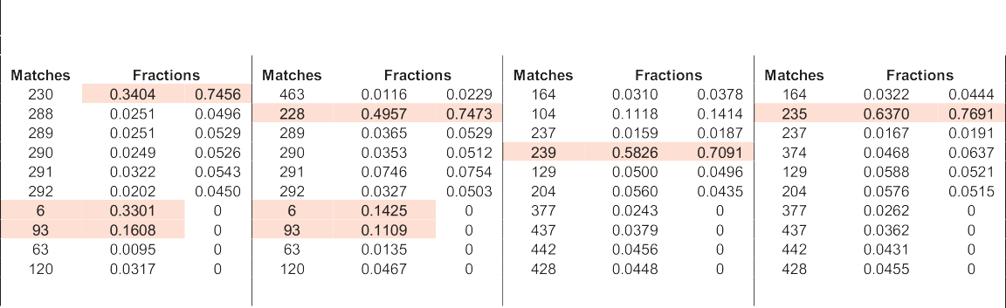

*D.A. Wood*

*Artificial Intelligence in Agriculture 5 (2021) 24*–*42*

36

Table 10 Prediction comparisons for some of the problematic data records associated with jumps in the trends of Figs. 7 and 8. The cells with shaded background distinguish the matched data records that dominate the predictions differently for the two solutions compared (benchmark solution and solution Evol2_6 optimized for RMSE).

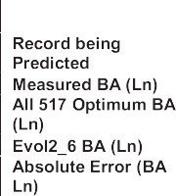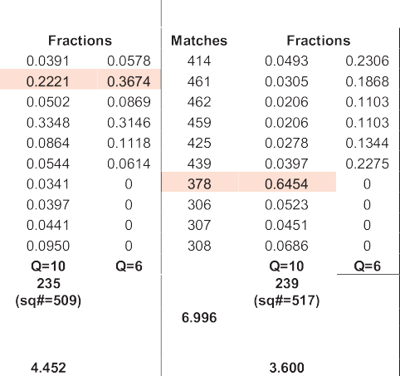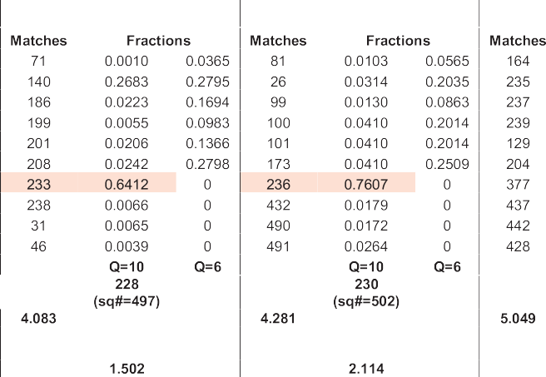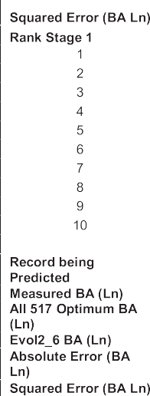

|  |  |  |  |  |
| --- | --- | --- | --- | --- |
|  | | | | |
|  |  |  |  |  |
|  |  |  |  |  |
|  | | | | |

|  |  |  |  |
| --- | --- | --- | --- |
|  |  |  |  |
|  |  |  |  |
|  | | | |

Note: The fractions of two high-performing solution are shown for each case: the first is for solution Evol2_6 (RMSE Optimized); the second is for the benchmark optimum solution.

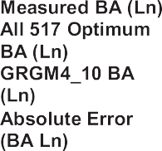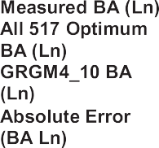

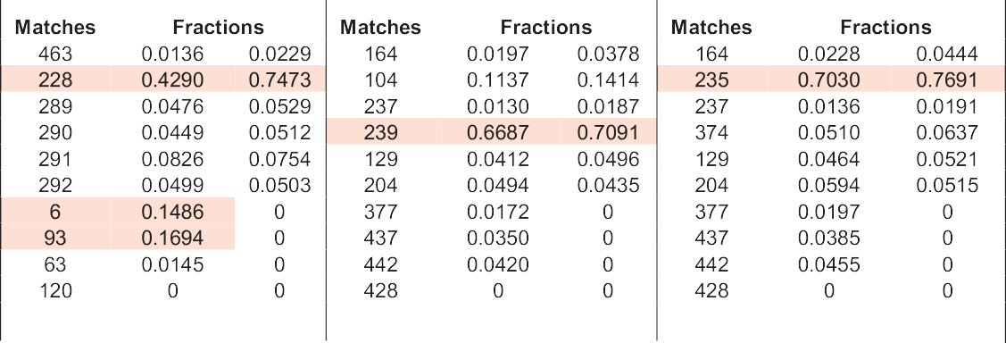

Table 11

Prediction comparisons for some of the problematic data records associated with jumps in the trends of Figs. 7 and 8 The cells with shaded background distinguish the matched data re- cords that dominate the predictions differently for the two solutions compared (benchmark solution and solution GRGM4_10 optimized for MAE).

|  |  |  |  |
| --- | --- | --- | --- |
|  | | | |
|  |  |  |  |
|  |  |  |  |
|  |  |  |  |
|  |  |  |  |
|  |  |  |  |
|  |  |  |  |
|  |  |  |  |
|  | | | |

Note: The fractions of two high-performing solution are shown for each case: the first is for solution GRGM4_10 (MAE Optimized); the second is for the benchmark optimum solution.

Many of the subsets used to establish the mean values for the regression-based and statistically-based machine learning models eval- uated in multi-case studies are likely to have involved a degree of overfitting. However, evaluating their BA prediction performance with relatively small testing subsets of data records is unable to reveal this

due to a lack of transparency with repsect to each data record predic- tion. On the other hand, the two-stage prediction process involved in the TOB models clearly reveals those cases with solutions generated from small tuning and testing subset samples for which some degree of overfitting has occurred. These are the cases where the TOB stage 2

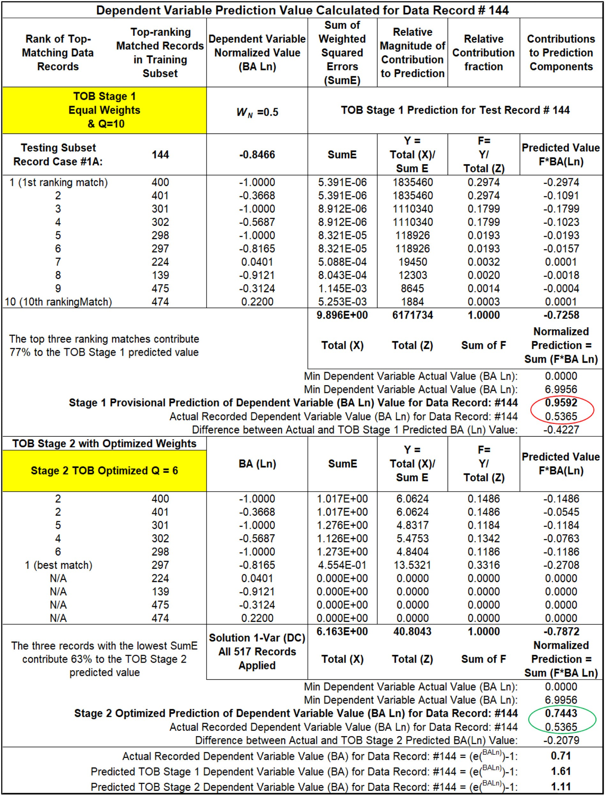

solutions generate lower prediction accuracy than TOB stage 1 solutions when applied to the full dataset (Tables 6 and 7).

The TOB method provides forensic auditing capabilities for each pre- diction made by transparently providing access to the data matching

and variable error weighting in each prediction calculation (Tables 9 and 10). It is this identification of the best matching data records, and their contributions to each data record predictions, that represents the true data mining benefit of the TOB algorithm. This enables it to provide

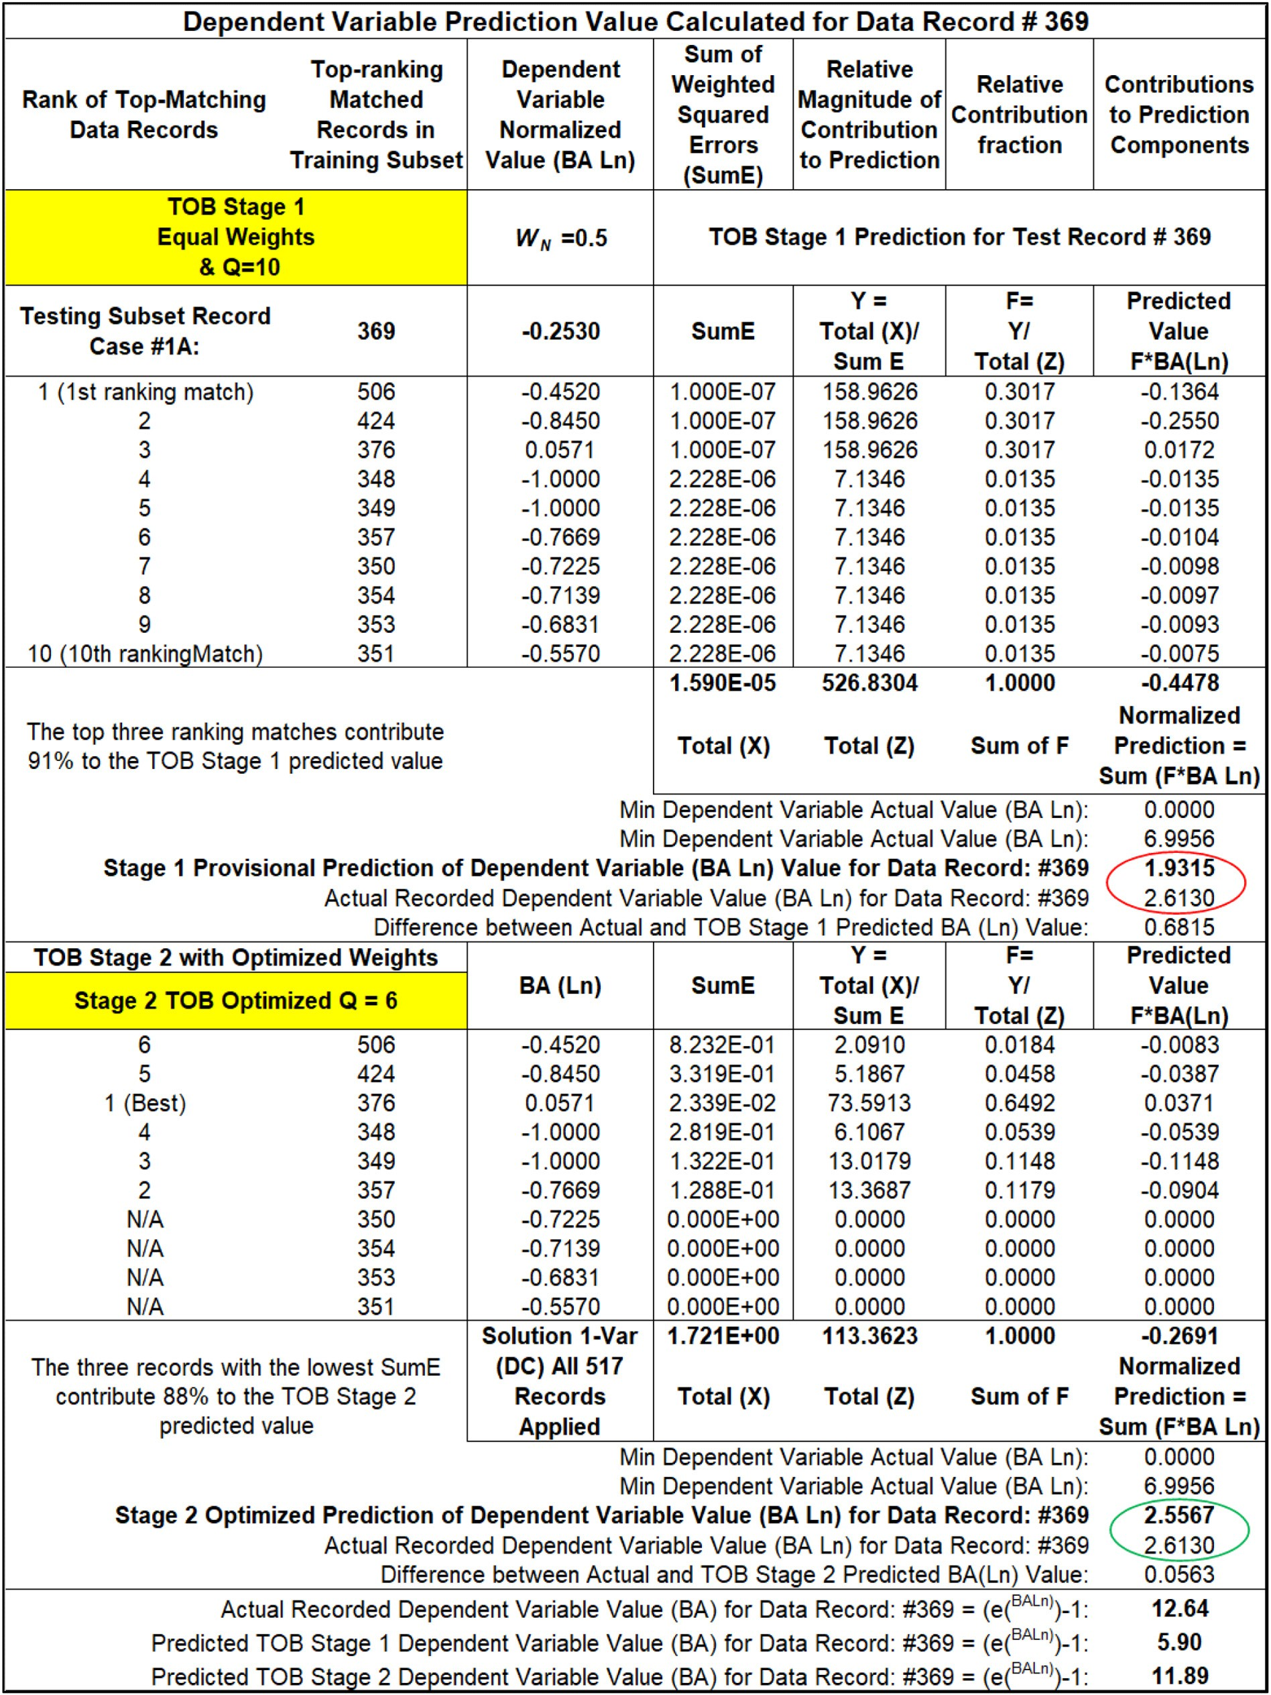

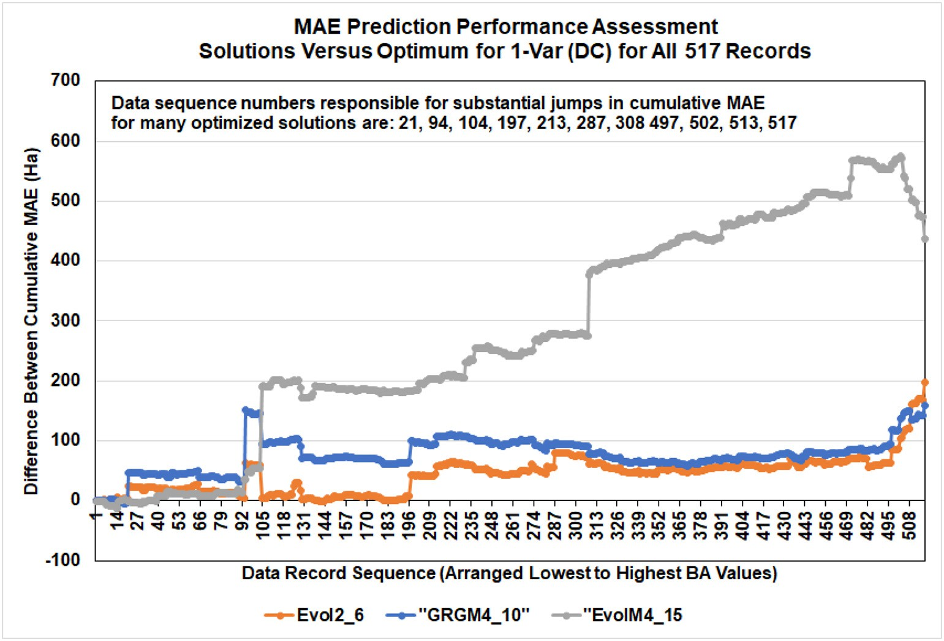

Fig. 7. Cumulative solution MAE differentials for Table 8 solutions versus “Best Solution Found” (MAE = 12.717 Ha; 1-Var (DC) model applied to all 517 data records). Noticeable jumps in these trends are linked to the prediction differences for a small group of data records for which the sequence order is listed in the graph.

ecological insight for each of its predictions. This capability differenti- ates the TOB method, in a positive way, from the machine learning algo- rithms that use regression, statistical or probabilistic relationships between the variables, which inhibit transparency and ready-access to the underlying details for individual predictions.

Graphical presentations of cumulative prediction error (Fig. 3) help to provide insight to a models prediction performance. It is useful to compare cumulative prediction error trends for the two predictions generated for each data record by the TOB algorithm. This reveals

exactly for what parts of the total burned area distribution the predic- tions are being improved by the optimization process. The cumulative absolute error and squared error differentials between specific solutions are also usefully displayed as graphical trends (Figs. 5 and 6). Such dis- plays help to make choices concerning which prediction model is most useful for specific ecological purposes. The ability to drill down into the specific data record predictions (Table 10 and 11) and understand the data records influencing each prediction, in positive or negative ways, is a valuable feature unique to the TOB method. For forest fire

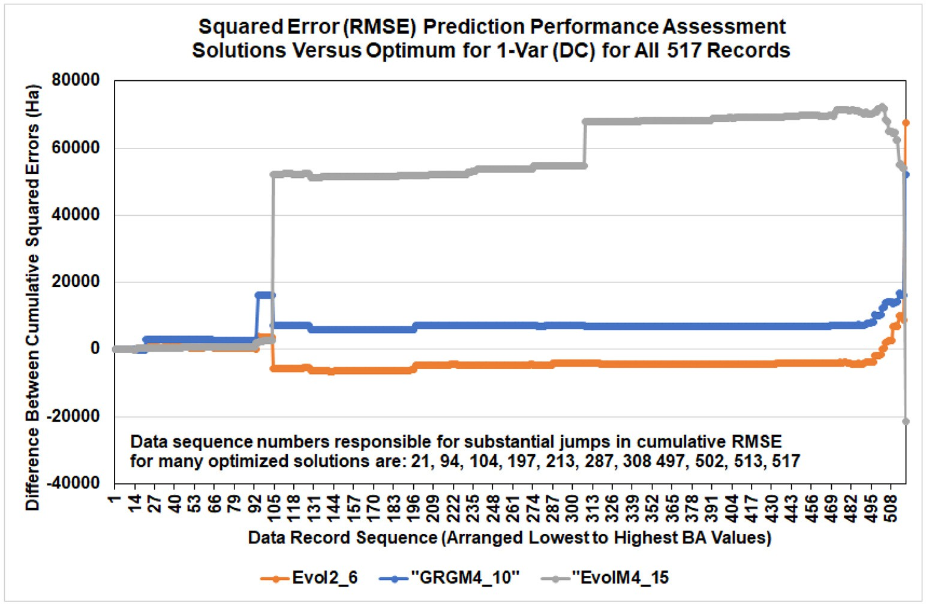

Fig. 8. Cumulative solution RMSE differentials for Table 8 solutions versus “Best Solution Found” (MAE = 12.717 Ha; 1-Var (DC) model applied to all 517 data records). Noticeable jumps in these trends are linked to the prediction differences for a small group of data records which for which the sequence order is listed in the graph.

predictions from datasets with many recorded input variables it makes ecological sense to move beyond regression-based machine learning and benefit from the auditability of optimized data matching to provide valuable insights from closely related historical records.

The detailed data mining made possible with the TOB solutions re- veals a good deal of useful information about each data record (burn event). Information about the influences on accurate and inaccurate predictions associated with specific optimized solutions. This can help to surface important ecological information that is useful in making ap- propriate response decisions to specific burn incidents. It identifies which are the most useful TOB models and the most influential variables that provide, and consistently justify, BA predictions. Such improved confidence in BA predictions, and the greater understanding of the fac- tors influencing each burn event derived from associated data mining, should lead to more appropriate responses to burn events as they hap- pen. Moreover, it should lead to more informed follow-up mitigation re- sponses that help to limit agricultural, ecological, environmental and forestry damage from similar incidents that might occur in the future.

1. Conclusions

An optimized data-matching machine learning algorithm can pre- dict the total burned areas of a well-studied forest fire dataset from Portugal (Montesinho Natural Park) to a high degree of accuracy. While doing so it provides exceptional data mining insights (that are not immediately obvious) with which to interrogate each historical burn event. The transparent open box (TOB) algorithm avoids the use of regression, correlation and statistical distribution assumptions in making its predictions and does not involve any hidden layers or com- plex calculations.

For the dataset studied, TOB feature selection sensitivity analysis identified drought code (DC) and relative humidity (RH) as the most in- fluential, of the thirteen variables considered, on TOB's total burned area predictions. The use of mean absolute error (MAE) and root mean squared error (RMSE) of the total burned area predictions separately as objective functions to minimize provides complementary informa- tion with respect to specific burned-area predictions from the highly positively skewed total burned area distributions of forest-fire datasets. The results indicate that transparent optimized data matching machine learning reveals more in wildfire datasets than regression-based ma- chine learning algorithms.

The consideration of cumulative absolute error (and squared error) differentials, displaying all data records, aid the comparisons between the detailed prediction analysis achieved by high-performing TOB models. Graphical representations of these cumulative error trends fa- cilitate data mining and reveal the few problematic data records that negatively influence the overall prediction accuracy achievable by spe- cific model structures. This enables model structures to be selected that focus prediction accuracy on specific sectors of the total burned area distributions and/or more broadly across the entire distributions. This ability provides knowledge that is beneficial for sound agricultural, ecological, environmental and forestry responses to better respond to and manage specific burn events and potentially limit the impacts of fu- ture similar events. The method proposed could be readily adapted to predict and data mine generic agricultural systems that are dependent on complex interactions between weather and environmental variables going beyond regression- and correlation-based methods.

Funding

This study received no funding.

Credit author statement

I am the sole author of this manuscript and responsible for every as- pect of its study and preparation.

Declaration of Interest

The author declares that he has no known competing financial inter- ests or personal relationships that could have appeared to influence the work reported in this paper.

References

Alkhatib, A.A., 2014. A review on forest fire detection techniques. Int. J. Distrib. Sens.

Netw. 10, 597368–597380. <https://doi.org/10.1155/2014/597368>.

Angayarkkani, K., Radhakrishnan, N., 2009. [Efficient forest fire detection system: a spatial](http://refhub.elsevier.com/S2589-7217(21)00011-8/rf0010) [data mining and image processing-based approach. Int. J. Comput. Sci. Netw. Secur. 9,](http://refhub.elsevier.com/S2589-7217(21)00011-8/rf0010) [100–107](http://refhub.elsevier.com/S2589-7217(21)00011-8/rf0010).

Artes, T., Cortes, A., Margalef, T., 2016. Large forest fire spread prediction: data and com- putational science. Procedia Comp. Sci. 80, 909–918. [https://doi.org/10.1016/j.](https://doi.org/10.1016/j.procs.2016.05.330) [procs.2016.05.330](https://doi.org/10.1016/j.procs.2016.05.330).

Castelli, M., Vanneschi, L., Popovič, A., 2015. Predicting burned areas of forest fires: an ar- tificial intelligence approach. Fire Ecol. 11, 106–118. [https://doi.org/10.4996/](https://doi.org/10.4996/fireecology.1101106) [fireecology.1101106](https://doi.org/10.4996/fireecology.1101106).

Caton-Kerr, S.E., Ali Tohidi, A., Gollner, M.J., 2019. Firebrand generation from thermally- degraded cylindrical wooden dowels. Front. Mech. Eng. 5, 32 12 pages. [https://doi.](https://doi.org/10.3389/fmech.2019.00032) [org/10.3389/fmech.2019.00032](https://doi.org/10.3389/fmech.2019.00032).

Coffield, S.R., Graff, C.A., Chen, Y., Smyth, P., Foufoula-Georgiou, E., Randerson, J.T., 2019. Machine learning to predict final fire size at the time of ignition. Int. J. Wildland Fire 28, 861–873. <https://doi.org/10.1071/WF19023>.

Cortez, P., Morais, A., 2007. [A data mining approach to predict forest fires using meteoro-](http://refhub.elsevier.com/S2589-7217(21)00011-8/rf0035) [logical data. In: Neves, J., Santos, M.F., Machado, J. (Eds.), New Trends in Artificial In-](http://refhub.elsevier.com/S2589-7217(21)00011-8/rf0035) [telligence, Proceedings of the 13th EPIA 2007 - Portuguese Conference on Artificial](http://refhub.elsevier.com/S2589-7217(21)00011-8/rf0035) [Intelligence, December, Guimarães, Portugal, pp. 512–52](http://refhub.elsevier.com/S2589-7217(21)00011-8/rf0035)3.

De Gennaro, M., Billaud, Y., Pizzo, Y., Garivait, S., Loraud, J.-C., El Hajj, M., Porterie, B., 2017. Real-time wildland fire spread modeling using tabulated flame properties. Fire Saf. J. 91, 872–881. <https://doi.org/10.1016/j.firesaf.2017.03.006>.

De Souza, F.T., Koerner, T.C., Chlad, R., 2015. A data-based model for predicting wildfires in Chapada das mesas National Park in the state of Maranhao. Environ. Earth Sci. 74, 3603–3611. <https://doi.org/10.1007/S12665-015-4421-8>.

Di Giuseppe, F., Remy, S., Pappenberger, F., Wetterhall, F., 2018. Using the fire weather index (FWI) to improve the estimation of fire emissions from fire radiative power (FRP) observations. Atmos. Chem. Phys. 18, 5359–5370. [https://doi.org/10.5194/](https://doi.org/10.5194/ACP-18-5359-2018) [ACP-18-5359-2018](https://doi.org/10.5194/ACP-18-5359-2018).

Fehrmann, S., Jahn, W., de Dios Rivera, J., 2017. Permeability comparison of natural and artificial *Pinus radiata* forest litters. Fire. Technol 53, 1291–1308. [https://doi.org/](https://doi.org/10.1007/s10694-016-0631-1) [10.1007/s10694-016-0631-1](https://doi.org/10.1007/s10694-016-0631-1).

Finney, M.A., 1998. [Farsite: fire area simulator-model development and evaluation. Tech-](http://refhub.elsevier.com/S2589-7217(21)00011-8/rf0060) [nical Report RMRS-4. USDA Forest Service, Rocky Mountain Research Station, Mis-](http://refhub.elsevier.com/S2589-7217(21)00011-8/rf0060) [soula, MT](http://refhub.elsevier.com/S2589-7217(21)00011-8/rf0060).

Finney, M.A., Cohen, J.D., McAllister, S.S., Jolly, W.M., 2013. On the need for a theory of wildland fire spread. Int. J. Wildland Fire 22, 25–36. [https://doi.org/10.1071/](https://doi.org/10.1071/WF11117) [WF11117](https://doi.org/10.1071/WF11117).

Forsell, N., Garcia, F., Sabbadin, R., 2009. [Reinforcement learning for spatial processes.](http://refhub.elsevier.com/S2589-7217(21)00011-8/rf0070)

[18th World IMACS/MODSIM Congress, Cairns, Australia, pp. 755–761](http://refhub.elsevier.com/S2589-7217(21)00011-8/rf0070).

Frontline Solvers, 2020. Standard Excel Solver - Limitations of Nonlinear Optimization. <https://www.solver.com/standard-excel-solver-limitations-nonlinear-optimization> [Accessed 3 January 2021].

Garzón, M.B., Blazek, R., Neteler, M., De Dios, R.S., Ollero, H.S., Furlanello, C., 2006. Predicting habitat suitability with machine learning models: the potential area of *Pinus sylvestris* l. In the Iberian Peninsula. Ecol. Model. 197, 383–393. [https://doi.](https://doi.org/10.1016/j.ecolmodel.2006.03.015) [org/10.1016/j.ecolmodel.2006.03.015](https://doi.org/10.1016/j.ecolmodel.2006.03.015).

Hedayati, F., Bahrani, B., Zhou, A., Quarles, S.L., Gorham, D.J., 2019. A framework to facili- tate firebrand characterization. Front. Mech. Eng. 5, 43 14 pages. [https://doi.org/](https://doi.org/10.3389/fmech.2019.00043) [10.3389/fmech.2019.00043](https://doi.org/10.3389/fmech.2019.00043).

Houtman, R.M., Montgomery, C.A., Gagnon, A.R., Calkin, D.E., Dietterich, T.G., McGregor, S., et al., 2013. Allowing a wildfire to burn: estimating the effect on future fire suppres- sion costs. Int. J. Wildland Fire 22, 871–882. <https://doi.org/10.1071/WF12157>.

Jaafari, A., Zenner, E.K., Panahi, M., Shahabi, H., 2019. Hybrid artificial intelligence models based on a neuro-fuzzy system and metaheuristic optimization algorithms for spatial prediction of wildfire probability. Agric. For. Meteorol. 266–267, 198–207. [https://doi.](https://doi.org/10.1016/j.agrformet.2018.12.015) [org/10.1016/j.agrformet.2018.12.015](https://doi.org/10.1016/j.agrformet.2018.12.015).

Li, J., Heap, A.D., Potter, A., Daniell, J.J., 2011. Application of machine learning methods to spatial interpolation of environmental variables. Environ. Model. Softw. 26, 1647–1659. <https://doi.org/10.1016/j.envsoft.2011.07.004>.

Liu, Z., Wimberly, M.C., 2016. Direct and indirect effects of climate change on projected future fire regimes in the western United States. Sci. Total Environ. 542, 65–75. <https://doi.org/10.1016/J.SCITOTENV.2015.10.093>.

Malarz, K., Kaczanowska, S., Kuakowski, K., 2002. Are forest fires predictable? Int. J. Mod.

Phys. C 13, 1017–1031. <https://doi.org/10.1142/S0129183102003760>.

Manzello, S.L., Suzuki, S., 2017. Generating wind-driven firebrand showers characteristic of burning structures. Proc. Combust. Inst. 36, 3247–3252. [https://doi.org/10.1016/j.](https://doi.org/10.1016/j.proci.2016.07.009) [proci.2016.07.009](https://doi.org/10.1016/j.proci.2016.07.009).

Martell, D.L., 2015. A review of recent forest and wildland fire management decision sup- port systems research. Curr. For. Rep. 1, 128–137. [https://doi.org/10.1007/s40725-](https://doi.org/10.1007/s40725-015-0011-y) [015-0011-y](https://doi.org/10.1007/s40725-015-0011-y).

McAllister, S., 2019. The role of fuel bed geometry and wind on the burning rate of porous fuels. Front. Mech. Eng. 5, 11. <https://doi.org/10.3389/fmech.2019.00011>.

McAllister, S., Finney, M., 2016. Burning rates of wood cribs with implications for wildland

fire. Fire. Technol 52, 1755–1777. <https://doi.org/10.1007/s10694-015-0543-5>.

Mcgregor, S., Houtman, R., Buckingham, H., Montgomery, C., Metoyer, R., Dietterich, T.G., 2016. [Fast simulation for computational sustainability sequential decision-making](http://refhub.elsevier.com/S2589-7217(21)00011-8/rf0135) [problems. Proceedings of the 4th International Conference on Computational Sus-](http://refhub.elsevier.com/S2589-7217(21)00011-8/rf0135) [tainability, New York, pp. 5–](http://refhub.elsevier.com/S2589-7217(21)00011-8/rf0135)7.

Miller, C., Tang, W., Finney, M., McAllister, S., Forthofer, J., Gollner, M., 2017. An investiga- tion of coherent structures in laminar boundary layer flames. Combust. Flame 181, 123–135. <https://doi.org/10.1016/j.combustflame.2017.03.007>.

Montgomery, C., 2014. [Chapter 13: fire: an agent and a consequence of land use change.](http://refhub.elsevier.com/S2589-7217(21)00011-8/rf0145) [In: Duke, J.M., Wu, J. (Eds.), The Oxford Handbook of Land Economics. Oxford Univer-](http://refhub.elsevier.com/S2589-7217(21)00011-8/rf0145) [sity Press, pp. 281–30](http://refhub.elsevier.com/S2589-7217(21)00011-8/rf0145)1.

Moon, K., Duff, T.J., Tolhurst, K.G., 2019. Sub-canopy forest winds: understanding wind profiles for fire behaviour simulation. Fire Saf. J. 105, 320–329. [https://doi.org/](https://doi.org/10.1016/j.firesaf.2016.02.005) [10.1016/j.firesaf.2016.02.005](https://doi.org/10.1016/j.firesaf.2016.02.005).

Peng, G., Li, J., Chen, Y., Norizan, A.P., Tay, L., 2006. High-resolution surface relative humid- ity computation using modis image in peninsular Malaysia. Chin. Geogr. Sci. 16, 260–264. <https://doi.org/10.1007/s11769-006-0260-6>.

Quill, R., Sharples, J.J., Wagenbrenner, N.S., Sidhu, L.A., Forthofer, J.M., 2019. Modeling wind direction distributions using a diagnostic model in the context of probabilistic fire spread prediction. Front. Mech. Eng. 5, 5 16 pages. [https://doi.org/10.3389/](https://doi.org/10.3389/fmech.2019.00005) [fmech.2019.00005](https://doi.org/10.3389/fmech.2019.00005).

Raposo, J.R., Viegas, D.X., Xie, X., Almeida, M., Figueiredo, A.R., Porto, L., Sharples, J., 2018. Analysis of the physical processes associated with junction fires at laboratory and field scales. Int. J. Wildland Fire 27, 52–68. <https://doi.org/10.1071/WF16173>.

Recknagel, F., 2001. Applications of machine learning to ecological modelling. Ecol. Model.

146, 303–310. <https://doi.org/10.1016/S0304-3800(01)00316-7>.

Rios, O., Valero, M.M., Pastor, E., Planas, E., 2019. A data-driven fire spread simulator: val- idation in Vall-llobrega's fire. Front. Mech. Eng. 5, 8 11 pages. [https://doi.org/10.3389/](https://doi.org/10.3389/fmech.2019.00008) [fmech.2019.00008](https://doi.org/10.3389/fmech.2019.00008).

Rodrigues, A., Ribeiro, C., Raposo, J., Viegas, D.X., André, J., 2019. Effect of canyons on a fire propagating laterally over slopes. Front. Mech. Eng. 5, 41 9 pages. [https://doi.org/](https://doi.org/10.3389/fmech.2019.00041) [10.3389/fmech.2019.00041](https://doi.org/10.3389/fmech.2019.00041).

Sanjuan, G., Margalef, T., Cortés, A., 2016. Applying domain decomposition to wind field calculation. Parallel Comput. 57, 484–490. [https://doi.org/10.1109/HPCSim.2015.](https://doi.org/10.1109/HPCSim.2015.7237080)

[7237080](https://doi.org/10.1109/HPCSim.2015.7237080).

Santoso, M.A., Christensen, E.G., Yang, J., Rein, G., 2019. Review of the transition from smouldering to flaming combustion in wildfires. Front. Mech. Eng. 5, 49 20 pages. <https://doi.org/10.3389/fmech.2019.00049>.

Saranya, N.N., Hemalatha, M., 2012. [Integration of machine learning algorithm using spa-](http://refhub.elsevier.com/S2589-7217(21)00011-8/rf0195) [tial semi supervised classification in FWI data. 2012 International Conference on Ad-](http://refhub.elsevier.com/S2589-7217(21)00011-8/rf0195) [vances in Engineering, Science and Management (ICAESM). IEEE, Nagapattinam,](http://refhub.elsevier.com/S2589-7217(21)00011-8/rf0195)

[pp. 699–702](http://refhub.elsevier.com/S2589-7217(21)00011-8/rf0195).

Sehgal, V., Getoor, L., Viechnicki, P.D., 2006. [Entity resolution in geospatial data integra-](http://refhub.elsevier.com/S2589-7217(21)00011-8/rf0200) [tion. Proceedings of the 14th Annual ACM International Symposium on Advances in](http://refhub.elsevier.com/S2589-7217(21)00011-8/rf0200) [Geographic Information Systems. ACM, Arlington, Virginia, pp. 83–90](http://refhub.elsevier.com/S2589-7217(21)00011-8/rf0200).

Sitanggang, I.S., Ismail, M.H., 2011. Classification model for hotspot occurrences using a decision tree method. Geomat. Nat. Hazards Risk 2, 111–121. [https://doi.org/](https://doi.org/10.1080/19475705.2011.565807) [10.1080/19475705.2011.565807](https://doi.org/10.1080/19475705.2011.565807).

Stocks, B.J., Lynham, T., Lawson, B., Alexander, M., Wagner, C.V., McAlpine, R., et al., 1989. Canadian forest fire danger rating system: an overview. For. Chron. 65, 258–265. <https://doi.org/10.5558/tfc65258-4>.

Subramanian, G.S., Crowley, M., 2018. Using spatial reinforcement learning to build forest wildfire dynamics models from satellite images. Front. ICT 5, 6. [https://doi.org/](https://doi.org/10.3389/fict.2018.00006) [10.3389/fict.2018.00006](https://doi.org/10.3389/fict.2018.00006).

Subramanian, S.G., Crowley, M., 2017. [Learning forest wildfire dynamics from satellite im-](http://refhub.elsevier.com/S2589-7217(21)00011-8/rf0220) [ages using reinforcement learning. Conference on Reinforcement Learning and Deci-](http://refhub.elsevier.com/S2589-7217(21)00011-8/rf0220) [sion Making. Ann Arbor, MI](http://refhub.elsevier.com/S2589-7217(21)00011-8/rf0220).

Tang, W., Finney, M., McAllister, S., Gollner, M., 2019. An experimental study of intermit- tent heating frequencies from wind-driven flames. Front. Mech. Eng. 5, 34. [https://](https://doi.org/10.3389/fmech.2019.00034) [doi.org/10.3389/fmech.2019.00034](https://doi.org/10.3389/fmech.2019.00034).

Taylor, S., Alexander, M., 2006. [Science, technology, and human factors in fire danger rat-](http://refhub.elsevier.com/S2589-7217(21)00011-8/rf0230) [ing: the Canadian experience. Int. J. Wildland Fire 15, 121–13](http://refhub.elsevier.com/S2589-7217(21)00011-8/rf0230)5.

Tohidi, A., Kaye, N.B., 2017. Comprehensive wind tunnel experiments of lofting and downwind transport of non-combusting rod-like model firebrands during firebrand shower scenarios. Fire Saf. J. 90, 95–111. <https://doi.org/10.1016/j.firesaf.2017.04.032>.

UCI Machine Learning Repository, 2008. Forest fires machine learning dataset with 517 data records and 13 attributes from Montesinho Natural Park in Portugal, January 2000 to December 2003 (deposited by P. Corez and A.D.J.R. Morais in February 2008). [https://archive.ics.uci.edu/ml/datasets/Forest+Fires](https://archive.ics.uci.edu/ml/datasets/Forest%2Bires).

Veraverbeke, S., Rogers, B.M., Goulden, M.L., Jandt, R.R., Miller, C.E., Wiggins, E.B., Randerson, J.T., 2017. Lightning as a major driver of recent large fire years in north American boreal forests. Nat. Clim. Chang. 7, 529–534. [https://doi.org/10.1038/](https://doi.org/10.1038/NCLIMATE3329) [NCLIMATE3329](https://doi.org/10.1038/NCLIMATE3329).

Wang, H., van Eyk, P.J., Medwell, P.R., Birzer, C.H., Tian, Z.F., Possell, M., Huang, X., 2019. Air permeability of the litter layer in broadleaf forests. Front. Mech. Eng. 5, 53 15 pages. <https://doi.org/10.3389/fmech.2019.00053>.

Wijayanto, A.K., Sani, O., Kartika, N.D., Herdiyeni, Y., 2017. Classification model for forest fire hotspot occurrences prediction using ANFIS algorithm. IOP Conf. Series: Earth En- viron. Sci. 54, 012059. <https://doi.org/10.1088/1755-1315/54/1/012059>.

Wood, D.A., 2016. Metaheuristic profiling to assess performance of hybrid evolutionary optimization algorithms applied to complex wellbore trajectories. J. Nat. Gas Sci. Eng. 33, 751–768. <https://doi.org/10.1016/j.jngse.2016.05.041>.

Wood, D.A., 2018. A transparent open-box learning network provides insight to complex systems and a performance benchmark for more-opaque machine learning algo- rithms. Adv. Geo-Energy Res. 2 (2), 148–162. [https://doi.org/10.26804/ager.2018.](https://doi.org/10.26804/ager.2018.02.04)

[02.04](https://doi.org/10.26804/ager.2018.02.04).

Wood, D.A., 2019a. Transparent open box learning network provides auditable predic- tions for coal gross calorific value. Model. Earth Syst. Environ. 5, 395–419. [https://](https://doi.org/10.1007/s40808-018-0543-9) [doi.org/10.1007/s40808-018-0543-9](https://doi.org/10.1007/s40808-018-0543-9).

Wood, D.A., 2019b. Sensitivity analysis and optimization capabilities of the transparent open box learning network in predicting coal gross calorific value from underlying compositional variables. Model. Earth Syst. Environ. 5, 753–766. [https://doi.org/](https://doi.org/10.1007/s40808-019-00583-1) [10.1007/s40808-019-00583-1](https://doi.org/10.1007/s40808-019-00583-1).

Yang, J., Liu, N., Chen, H., Gao, W., 2018. Smoldering and spontaneous transition to flaming over horizontal cellulosic insulation. Proc. Combust. Inst. 37, 4073–4081. [https://doi.](https://doi.org/10.1016/j.proci.2018.05.054) [org/10.1016/j.proci.2018.05.054](https://doi.org/10.1016/j.proci.2018.05.054).

Yongzhong, Z., Feng, Z.-D., Tao, H., Liyu, W., Kegong, L., Xin, D., 2004. [Simulating wildfire](http://refhub.elsevier.com/S2589-7217(21)00011-8/rf0285) [spreading processes in a spatially heterogeneous landscapes using an improved](http://refhub.elsevier.com/S2589-7217(21)00011-8/rf0285) [cellular automaton model. Geoscience and Remote Sensing Symposium, 2004.](http://refhub.elsevier.com/S2589-7217(21)00011-8/rf0285) [IGARSS’04. Proceedings. 2004 IEEE International. 5. IEEE, Anchorage, AK,](http://refhub.elsevier.com/S2589-7217(21)00011-8/rf0285)

[pp. 3371–3374](http://refhub.elsevier.com/S2589-7217(21)00011-8/rf0285).

Young, A.M., Higuera, P.E., Duffy, P.A., Hu, F.S., 2017. Climatic thresholds shape northern high-latitude fire regimes and imply vulnerability to future climate change. Ecography 40, 606–617. <https://doi.org/10.1111/ECOG.02205>.

Zhang, G., Wang, M., Liu, K., 2019. Forest fire susceptibility modeling using a convolutional neural network for Yunnan Province of China. Int J Disaster Risk Sci. 10, 386–403. <https://doi.org/10.1007/s13753-019-00233-1>.

Zhang, J.-H., Yao, F.-M., Liu, C., Yang, L.-M., Boken, V.K., 2011. Detection, emission estima- tion and risk prediction of forest fires in China using satellite sensors and simulation models in the past three decades – an overview. Int. J. Environ. Res. Public Health 8, 3156–3178. <https://doi.org/10.3390/ijerph8083156>.